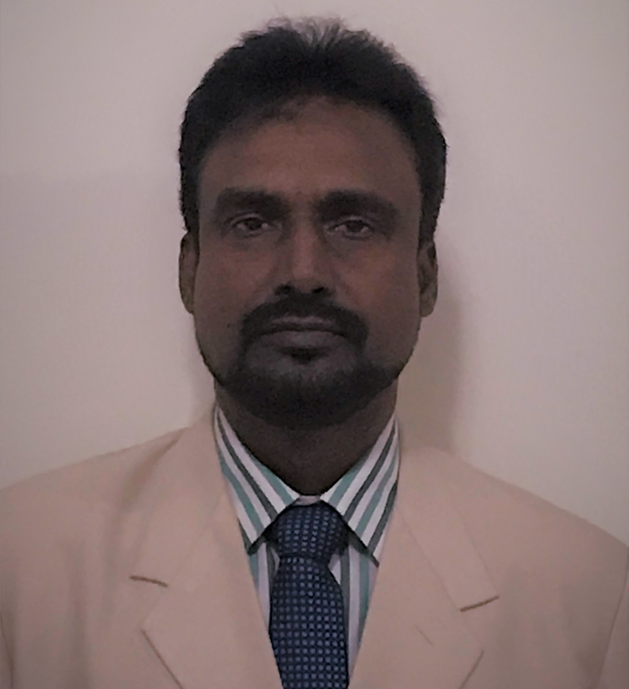

**Firoz Mahammad Mallick**

**Grade A MEP professional**

BE (Electrical) from Calcutta university, Qatar UPDA certified Grade A Engineer and Qatar Civil Defense approved Engineer

[firoz.alisa.omar@gmail.com](mailto:firoz.alisa.omar@gmail.com), skype- firozalisa, Mob +974 50411159

---------------------------------------------------------**Objective**-----------------------------------------------------------------

Aspire to take bigger challenge & lead a MEP division. In all ways, my association will improve company portfolio

---------------------------------------------------------**Summary**-----------------------------------------------------------------

An accomplished MEP professional with more than 27 years of experience including 19 year in Gulf and leading MEP team/department in all aspects of works to ensure timely completion of project within approved budgets without compromising on Quality & Safety.

**Strengths & skill:**

* **Technically astute**
* Ensuring that all projects are delivered on-time, within scope and within budget
* Coordinating internal resources and third parties/vendors for the flawless execution of projects
* Developing a detailed project plan to track progress
* Ensuring resource availability and allocation
* Using appropriate verification techniques to manage changes in project scope, schedule and costs
* Providing inputs as value Engineering and guiding design consultants and sub-contractors to optimum technical design.
* Measuring project performance using appropriate systems, tools and techniques
* Reporting and escalating to top management as needed
* Managing the relationship with the client and all stakeholders
* Performing risk management to minimize project risks
* Establishing and maintaining relationships with third parties/vendors

*■ Estimation & Bidding ■ Post bidding clarification, negotiation & finalization of offer*

*■ Project management ■Construction management ■Operation management ■Office administration*

*■Engineering & design / detail engineering ■Value engineering ■Cost control*

*■ Vendor finalization ■Technical submittal & approvals ■Procurement*

*■Installation & Inspections ■Testing & commissioning*

*■Trouble shooting and maintenance of MEP systems during defect liability period (DLP)*

*■Quality control ■Safety*

*■Monitoring program and project controls KPIs*

*■*Developing action and recovery plans to support program delivery on time

*■Authority coordination/ approvals*

*■Invoicing & payment ■Management reporting ■Business development ■Mentoring & team building*

**Major Achievement:**

►Successfully completed major MEP & Fire Fighting system installation, testing, commissioning, authority inspection etc for Residential, Commercial, Utility & industrial buildings such as 11 KV system, LV system, Fire alarm system, BMS, CCTV, SMATV, SCS, LCS, CBS, Fire curtain, sprinkler system, pre-action system, deluge system, smoke extraction system, clean agent fire suppression system, FOAM system, N2 pressurization system, fire alarm system.

►Successfully completed 3 no retail development (Al Meera) projects at Lusail, Qatar within budget and secured confidence of client QD. Introduced & Implemented new measures to control labour and material wastage to increase profit.

►Singlehandedly trained people & obtained Kahramaa grade A license for the company RTC within a short period of time which is helping RTC to secure contracts.

►Successfully completed Sohar college laboratory project, Oman and managed to turn loss into profit with the support from GM. Also successfully completed many projects within budget for client in Oman like Royal Court Affairs, ROP, RAFO, MODES, Muscat Municipality.

►Singlehandedly trained technician for 11 KV jointing & obtained 11 KV license for the company Al Khalili within 3 month.

**---------------------------------------------------------Certification--------------------------------------------------------**

**Qatar UPDA certified ‘Grade A ‘Electrical Engineer (Reg no 4966) and Qatar Civil Defense certified**

**---------------------------------------------------------Education--------------------------------------------------------**

**Bachelor of Electrical engineering from B.E. College (Calcutta University), WB, India**

---------------------------------------------------------Work Experience--------------------------------------------------------

**Current: Project manager / Technical leader– ELE (MEP) - RTC, Qatar**

Projects: 3 no retail commercial complex & 3 no 11KV/440V S/S (MEP QR 35 million) for client Qatari

Diar, Al Mana warehouse & labor accommodation (MEP QR 10 million, 4 no high end villa (MEP QR 15 million) for Al Balagh family, MEP infrastructure works for Dukhan Air base (QR 13million, Road landscaping works for Ashghal and other medium & small nature multiple projects are in progress for

client QBG, Ashghal, Qatar armed forces.

Achievement: Successfully led the team to complete 3 no retail commercial buildings within budget at Lusail city for client

Qatari Diar.

Reduced project cost by carrying out minute detail engineering & re-engineering, value engineering, increasing productivity & controlling rework.

Mentoring & developing engineering team. Developed & maintaining cordial relation with consultant.

Worked & obtained grade A contractor license from Kahramaa and Qatar Civil defence.

Liasioning with Kahramaa for all LV & HV approval and inspection; Liasioning with Civil Defence; Estimation & tendering; Detail engineering/designing; Procurement

Execution; Quality control & safety; Inspection, testing & comm and project hand over

Billing; Project reporting; Business development

Dec 2012 to Dec 2016: MEP Manager, Al Khalili, Oman

Projects worked: Sohar college of science laboratory building, Musannah new radar operation control room,

Ghala masjid, Al bustan hotel 5 star kitchen, slaughter house, various police station/complex (client- ROP, MODES, MOHE, RCA, MM) and many 11/415V S/S.

Achievement: Managed multiple projects within budget.

Reduced project cost by carrying out re-engineering and value engineering.

Managed to reduce project cost by controlling rework and improving productivity.

Mentored juniors by identifying & providing necessary trainings.

Developed in house design team, HVAC team and 11 KV team.

Successfully integrated MEP division into the civil division.

Obtained 11 KV license for the company from DCRP.

Developed & maintained good relation with consultant & client.

Jan 2012 Sept 2012: Sr Project Manager (MEP), Mechel engineering WLL, Doha, Qatar

Projects worked: US air base network comm center, Qatar university student housing Project

Achievement: Managed projects within budget. Reduced project cost by carrying out re-engineering and value

engineering and improving productivity. Developed & maintained good relation with consultant & client.

Sept 2008 to Dec 2011: Sr MEP Engineer (client side), Dubai Electricity & Water Authority, Dubai, UAE

Projects worked: 132 KV substations (each @ USD 100m), 400 KV substations (each @ USD 200m)

Achievement/role Reviewing & approving conceptual and detail engineering design, engineering calculations, data

sheets, drawings and specifications for MEP services & Solar project for HV substations, HV cable tunnel and office buildings, Reviewing & approving materials, ITP, SAT, FAT, method statements, shop drawings, as-fitted drawings and O&M manual, Inspecting equipment at factory and at site, Liaising with in-house team, design consultant, contractor and architects, Managing a team of engineers & site supervisors, Complying with LEED requirement

May 2006 to Aug 2008: Project Manager (Ele/MEP), Al Naboodah Engineering MEP LLC, Dubai, UAE

Projects worked: Dubai Palm Jumeirah MEP works, Dubai discovery garden housing & Infra works

Achievement: Managed infrastructure development & building services MEP projects at Palm Jumeirah and

Discovery garden housing project. Managed projects within budget & schedule. Managed to reduce project cost by improving productivity. Mentored juniors. Developed & maintained good relation with consultant & client. Developed strong relation with DEWA.

May 2002 to April 2006 Project Engineer – Electrical

Airmech WLL, Bahrain (Middle East)

Projects worked: ALBA health centre, HSBC bank HQ, BAPCO

May 1999 to April 2002 Electrical Engineer

Mannai Engineering Company Limited, Dammam, Saudi Arabia (Middle East)

Projects worked: AL Hasa Intercontinental hotel (5 star), SJT factory (textile)

1995 to 1999 Field Electrical Engineer

Engineers India Limited, New Delhi, India (consultant in oil & gas, petrochemical sector)

Projects: plants, fuel filling station, remote control buildings, electrical substations, operator shelters and

switchyard facilities in the oil & gas/petrochemical industry for IPCL, ONGC, GAIL, HPL

1993 to 1995 Engineer – Customer Support

Gujarat Hi-Rel Controls Limited, Kolkata, India

1992 to 1993 Engineer – Customer Support

Welman Incandescent India Limited, Kolkata, India