**UDAYKUMAR GALUGU** (M.B.A)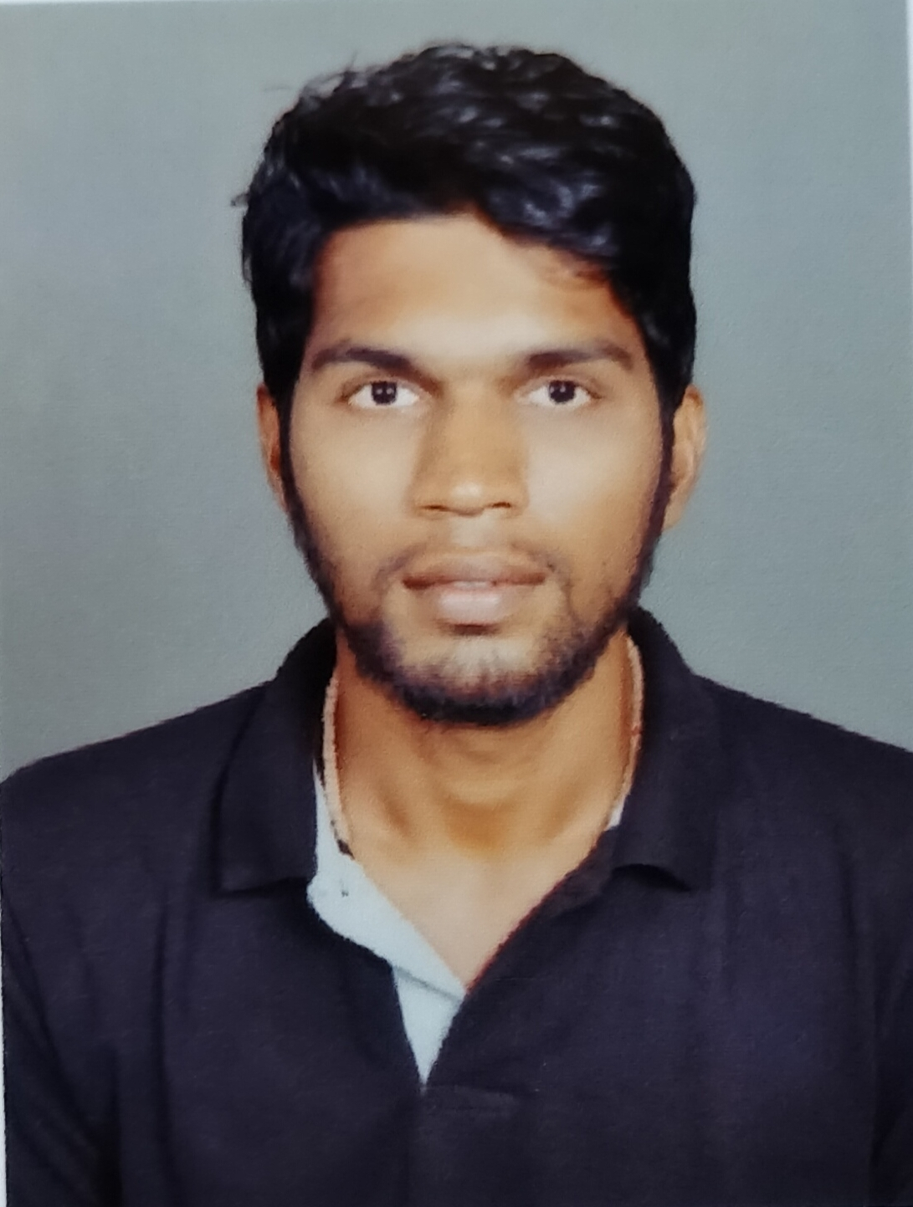

KLS’s GOGTE INSTITUTE OF TECHNOLOGY(Autonomous under VTU university) ,UDYAMBAG, BELAGAVI-590008

**EMAIL*:*** *[udaykumargalugu24@gmail.com](mailto:udaykumargalugu24@gmail.com)*

**Mobile No:** 9405353141

**Date of birth :** 24th July 1997

**ADDRESS:** 6TTR military camp ponda goa

**OBJECTIVES:** To make contribution to the organization to the best of my ability and to develop new skills and share my knowledge while interacting with others and achieve new heights.

**EDUCATION:**

**2003-2013**:- SSLC. ***44.00%***

**Dada vaidya high school ponda goa**

**2013-2015**:- Arts ***56.02%***

**A.V.P.M ponda goa**

**2015-2018**:- Bachelor of computer applications ***68.03%***

**G.V.M’s ponda goa**

**2018-2020**:- Master of business administration Specialization on (Finance & HR) **64.0%** **(Autonomous under VTU university)KLS’s Gogte institute of technology, Udyambag, Belagavi.**

**LANGUAGES KNOWN:-** English, Hindi, Telugu, Konkani & Marathi.

**HOBBIES:** Cooking, Playing Cricket & Badminton.

**PROJECTS:**

* In BCA Last sem Developed an web site called **“SMART BASKET”** a use for e-commerce.
* In MBA 3rd Semester I did Two Months of internship on **‘A Study on Inventory management‘** at **MRF Ltd. (Ponda Goa)**

**CERTIFICATIONS:**

* Cambridge Assessment English Passed and Awarded with A2 grade.
* Certified with Google Digital Unlocked on ‘The Fundamentals of Digital Marketing’.
* Certificate of Training on SPSS Business Analytics.
* Certificate of Presentation on The Impact of Bank Default on Banking.

**EXTRA CURRICULAR EXPERIENCES:**

* Participated in ADVIT Poster making of a company in Avalanche FEST of GIT 2018.
* Managed all Catering works and escorting at GIT MBA’s fest ADVAITH 2019.

**SPORT:**

* Four National level in Teakwondo.
* One International level in Teakwondo.

**PROFESSIONAL SKILLS:** MS word, Power point, excel, IBM SPSS, Microsoft visual studio, Android Studio, WordPress, JavaScript, oracle, Dream weaver, Sql, Anaconda.

**PERSONAL SKILLS:** Communication, Leadership, Responsible, positive attitude, decision making, self motivation, time management, quick learner, adaptable.

# 