**AKANSHA RANA**  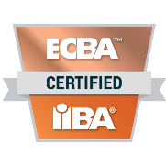



**About Me**

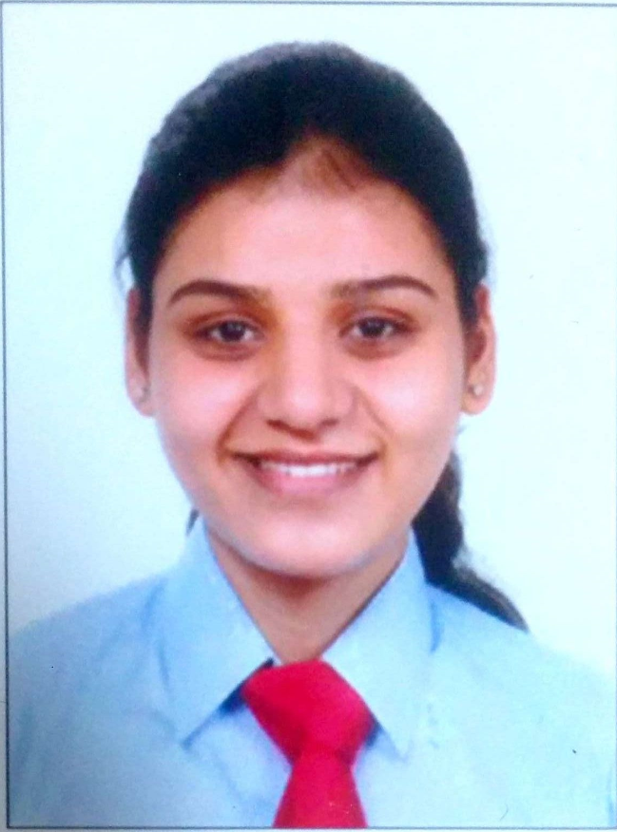



Delhi, India



January 20, 1993



6 Years



Rana.akansha93@gmail.com



+91.8968244656

IT Professional with an overall experience of 6 years in techno functional roles as Application Support Analyst and Business Analyst. Striving to leverage my IT and Business Analysis Skills to succeed in an environment of growth and excellence and earn a job which provides me job satisfaction and self- development and help me achieve personal as well as organizational goals.



**Professional Qualifications and Affiliations**

* **ECBA certification in Business Analysis from IIBA (International Institute of Business Analysis).**
* **CCBA Certification in Business Analysis from SimpliLearn.**



**Career Highlights**

* Fair amount of knowledge on ADFS (Active directory federation services) technology and Deployments.
* Experienced in configuring monitors on NAGIOS Health check and resolving the alerts.
* 5+ years of work experience in web based and Desktop applications support and commendable knowledge Microsoft Technologies .NET, SQL Server 2008/2014 and Windows server management.
* Knowledge on **ITIL Process** (Incident, Problem, Change, Knowledge and Release Management etc.). Knowledge on HP Service Manager and Service-NOW (ticketing tool) and its utilities.
* Near to 1 year of experience in performing Business Analysis, client requirement analysis.
* Extensive hands on experience in creation of project documentation like Business case, Functional Requirements Speciation documentation, acceptance criteria, support handover documentation.
* Working experience in usage of Azure DevOps and VSTS tool..
* Conduct levels of testing including functional, regression, user acceptance and integration testing.
* Commendable exposure to enterprise architectures while working in support organization and connected support model
* Excellent communication and interacting skills with clients globally.



**Skills**

* Web Technologies: ASP .NET, HTML, XML, CSS, Java Script
* Languages: C#, C++
* IIS
* NAGIOS X1
* ADFS (Active Directory Federation services)
* RDBMS: Microsoft SQL Server, Oracle
* Requirement Analysis
* Cost/Effort Estimation
* GAP and Impact Analysis
* Functional Domain ENU (Energy, Natural resources and Utilities)
* ITIL



**Work Experience**

**3M Trimodal, Bangalore India April 2020 – Present**

**Project Name: Health Check Global**

**Role: Business Analyst (Apr 2020 – Till Date)**

**Client: Aquity**

**Key Skills:** SQL, Oracle, NAGIOS X1, ADFS technology, IIS

**Highlights**

* Worked on NAGIOS X1 Healthcheck Dashboard to configure monitors for different servers to generate alert emails.
* Gained knowledge on Transcription process and job monitoring and processing.
* Worked on ADFS technology and participated in deployments.
* Resolved tickets and alerts related to server issues.
* Monitored Application Dashboards and resolved issue related to the alerts.

**Wipro Technologies, Bangalore India August 2014 – March 2020**

**Project Name: Shell Downstream Manage Threat and Opportunities Development and Implementation**

**Role: Business Analyst ( Jan 2019 – Till Date)**

**Client: Shell Downstream**

**Key Skills:** Business Analysis, Communication with Key Stake holders, Strategic analysis and work flow definition, Usage of Business/Requirement Analysis Tools, Power BI.

**Highlights**

* Played a vital role in all the stage gates process from concept development to production implementation.
* Worked closely in upgrading the work flow of the reliability process and integration strategy how the work flow can be made a part of IT road map.
* Involved in concept development, Business Case document creation, analyze and document client requirements through document analysis, workshops and client interactions as a part of stage gate 2.
* Extensively used Azure DevOps tool to create feature, product backlogs tracking, back log prioritization, Kanban dashboards.
* Supervised and liaised between business and technical personnel to ensure a mutual understanding of processes and applications. Create SRS documents such that solution being developed completely adheres to client’s expectations.
* Conducted 5+ levels of testing including functional, regression, user acceptance, integration and performance to verify the client’s needs are met.
* Participated in steering committee discussion in providing the updates of project status.
* Defined and designed the IRM control execution and test plan.

**Project Name: Shell Downstream Mitigate Threat to Availability Enhancements and Development**

**Role: Developer and Senior Developer (Aug 2016 – Dec 2018)**

**Client: Shell Downstream**

**Skills:** ASP .NET, HTML, CSS, Java Script, Microsoft SQL Server 2008/2014, Azure Server Migration

**Highlights**

* Worked as web Developer for enhancement of .Net based application
* Worked extensively in the creation of DB objects like stored procedure, functions, triggers and etc.
* Involved in IIS web server and database server configurations on Azure Cloud platform.
* Created unit test cases and executed system and regression test scenarios.
* Involved in technical peer reviews.

**Project Name: Shell Downstream Manufacturing AOMS Support**

**Role: Support Analyst and Developer (Apr 2015 – Till Date)**

**Client: Shell Downstream**

**Skills:** ASP .NET, Microsoft SQL Server, Oracle

**Highlights**

* Resolved tickets within the SLA (as per the project norms).Participated in code enhancements/CRs (Change Requests).
* Performed Root Cause Analysis (RCA) for the incidents and problems and document the same.
* Proactive issue identification and resolution –Monitoring of the application is done as per the frequency. Co-ordinate with onsite teams for issue allocation and resolution.
* Effective communication with the clients globally.
* Successfully delivered projects under strict schedules and quality control as a part of RFS (Request for Service).
* Participated in team meeting and activities. Spent qualitative time in helping other team members and solve project specific challenging technical problems.
* Performed disaster recovery and health checkup.
* Involved in Creation, Development and Deployment of windows/console/web based applications.
* Worked with solution delivery team in migrating and designing legacy applications to latest platforms

**Project Name: PRISM**

**Role: Developer (Aug 2014 – Apr 2015)**

**Client: HP**

**Skills:** ASP .NET, Microsoft SQL Server, Oracle

**Highlights**

* Worked as UI Developer.
* Worked in the creation of DB objects like stored procedure, functions, triggers and etc.
* Created unit test cases and executed system and regression test scenarios.



**Education**

**Bachelor, Technology (ECE)** Graduated, 2014Chitkara School of Engineering **CGPA-8.7**  
& Technology Division 1  
Baddi, Himachal Pradesh

**Class XII** Graduated, 2010K.V Sector 47, Chandigarh **Marks 84.2 %**  
C.B.S.E Board Division 1  
Chandigarh

**Class X** Graduated, 2008K.V Sector 47, Chandigarh **Marks 94%**  
C.B.S.E Board Division 1  
Chandigarh



**Personal Details**

Father’s Name: Mr. Bir Singh Rana

Marital Status: Single

Nationality: Indian

Language Proficiency: English and Hindi

Gender: Female

Personal Interests: Painting, Listening to Music, Participating in Co-Curricular Activities

**Declaration**

I, Akansha Rana, hereby declare that the information contained herein is true and correct to the best of my knowledge and belief.

____________________________  
Akansha Rana Bangalore, Karnataka  
 1st January, 2020