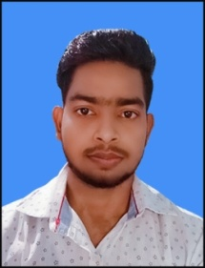 CURRICULAM VITAE

**SHAHID RAZA**

Mob No:-**+91-6203369729,7870814925**

Email Id:-shahidraza2498@gmail.com

**Career Objective**

To maximize profit for the organization by using my skill set with professional achievement and honesty

**Academic Qualification**

|  |  |  |  |  |
| --- | --- | --- | --- | --- |
| **Qualification** | **Board/University** | **Institution** | **Year of passing** | **CGPA/Percentage** |
| **B.A** | Vinoba bhave University | Ananda college HAzaribagh | appering |  |
| **Higher secondary** | Jharkhand Academy Council, Ranchi | Inter Science College Hazaribagh | 2018 | 47.2% |
| **Matric** | C.B.S.E | D.A.V Public School,urimari | 2016 | 72.5% |

**Experience**

|  |  |
| --- | --- |
| **FIRST AID (**MTS)  REGISTRATION NO. :378/2014-15 | **6 MONTHS** |
| **MARKETING**(direct selling) | **2 YEAR** |
| **ALUMINIUM WORK**( door, window, arch, lower) | **6 MONTHS** |
| **COVID(**AYUSHMAN HOSPITAL) | **4 MONTHS** |

**Technical Skills**

* Basic knowledge of computer.
* Knowledge of MS-office and Internet Application.

**Personal Details**

S/O : Nizamuddin

Date of Birth : 01/12/1999

Permanent Address :Bhelwara Hazaribagh (Jharkhand ) 825301

Correspondence Address :at+post- sayal, Dist- Ramgarh, jharkhand , pin - 829125

Languages Known : English, Hindi and Urdu.

Hobbies : Watching movies ,Playing games

**Declaration**

I hereby declare that the above information furnished is true to the best of my knowledge and belief.

Place: sayal. (Shahid raza)