**S.ARUN KUMAR**

**(ERP SOFTWARE MARKETING EXECUTIVE).** 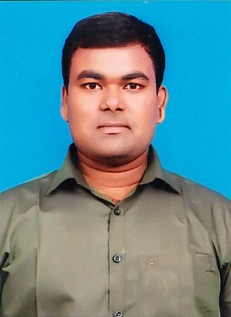

**Phone** 9944843188. **LinkedIn** https://www.linkedin.com/in/arun-kumar-6a621116a

**E-mail** [kumararunrun0507@gmail.com](mailto:kumararunrun0507@gmail.com) **Address** M-213 TNHB,KRISHNAGIRI(d/t),Tamilnadu-635001

**Date of birth** : 07/09/1993. **Age** : 27 **Gender** : Male

**Experience**

**2015(April) - 2017(November). MARUTI SUZUKI CAR DEALERSHIP KRISHNAGIRI**

**SALES EXECUTIVE(AUTOMOBILE)**

2.5 years experience in Automobile sales and marketing

Roles: collecting enquiries from various sources to build relationship with the customers to do various processes live closing deal raising invoices and make arrangements to register and deliver to vehicles.

**2017(November) – present VOICESNAP SERVICES PRIVATE LIMITED CHENNAI**

**SALES ACCOUNT MANAGER(ERP SOFTWARE)**

more than 3 years in ERP software sales and marketing

Roles:we are doing billing software and communication solutions lile school and parent APP which will be more helpful for both school and parents to communicate and to conduct online classes.

Total experience in both above organization is 6 years in sales and marketing.

**Education**

|  |  |  |  |  |
| --- | --- | --- | --- | --- |
| Course | Institution | Board/University | Year of Completion | Mark%/CGPA |
| BE-EEE | Adhiyamaan College of Engineering | Anna University | 2015 | **6.2** |
| XII | Cambridge Matriculation Higher Secondary School | Matriculation | 2011 | 66.75 |
| X | Vailankanni Matric Higher Secondary School | State Board | 2009 | 67.2 |

**Highlights**

* Game changer
* Creative
* Motivational
* Easy learner
* Team player
* Analyst

**Hobbies**

* Driving
* Reading books(automobile)
* Crafting
* Cycling
* Swimming
* Politics
* Traveling

Here i confirm that the information given above are correct and true to my knowledge

**Date:19/04/2021**