Resume

AMARNATH . A  S/O Anjaneyulu.c  NO.4 4th cross pampa nagar  Near Ganesh Temple  Yeshwanthpur  Bangalore-560022  Mobile: +918884906384  E-mail: amarnath6060@gmail.com |  | 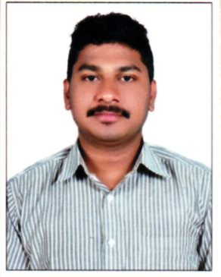

Education

S S L C
PU C

IT Proficiency

Computer | Basic skills
Application Package | Internet and E-mail applications

Work Experience

- Reliance digital as a sa worked at 2years.
- Croma as a sa worked 1years.
- Reliance digital xpress as working store leader past 1years .

Linguistic Skills

LANGUAGE | READ | WRITE | SPEAK
English | Yes | Yes | yes
Kannada | Yes | Yes | yes
Telugu | Yes | No | yes
Tamil | No | No | yes
Hindi | yes | No | yes

Summary

- Desire to learn and work hard, Committed Team player, adaptability,
- Hobbies include singing and listening music.

Personal Details

Date of birth : 04.08.1991
Nationality : Indian
Marital status : Single
Sex : Male
Religious : Hindu

Reference

Furnished promptly upon request with supporting documents

Declaration

I hereby declare that the above stated are true and correct to the best of my knowledge and belief.

Place:-Bangalore
Date :- ( Amarnath .A )

