**RESUME**

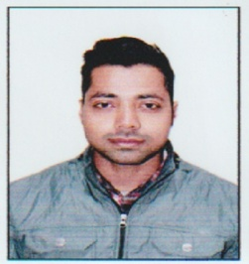

**DEEPAK KUMAR**

**109 New Park Road**

**Gandhi Gram**

**Dehradun , Uttarkhand (248001)**

**Mob.no 7906269334,8273317085 Email- sakki8326@gmail.com**

|  |
| --- |
| **CAREER OBJECTIVE** |

To work with an organization where I can prove my abilities .My aim is to grow with company and contribute my utmost skills in the realization of personal and organization objective.

**EXPERIENCE**

* Four Year work experience in SALT KITCHEN STUDIO as a **Store** Supervisor.

* One Year work experience in SINGH CONSTRUCTION as a **Site** Supervisor.

* Two Years work experience in **BAJAJ FINSERV** as aCollection Executive.

**EDUCATIONAL QUALIFICATION**

* Post Graduation (M.A) from H.N.B Central University 2020.

* Graduate (B.A) from S.D.S.U.V University in 2018.

* Intermediate from N.I.O.S Board in 2014.

* High School from C.B.S.E Board in 2010.

**PROFESSIONAL QUALIFICATION**

* Three Year Polytechnic Diploma in Civil Engineering in 2017.

* Master Diploma In Computer Application And Management in 2012.

**HOBBIES**

* Playing cricket.

* Listening music.

**PERSONAL DETAIL**

Father’s name : Jai Singh

Date of Birth : 21-10-1994

Gender : Male

Marital status : Unmarried

Language Known : Hindi & English

Nationality : Indian

**DECLARATION**

I herby certify that all information given above is true to the best of my knowledge.

**Place : Dehradun**

**Date : DEEPAK KUMAR**