**RESUME**

**Name : Ashoka** 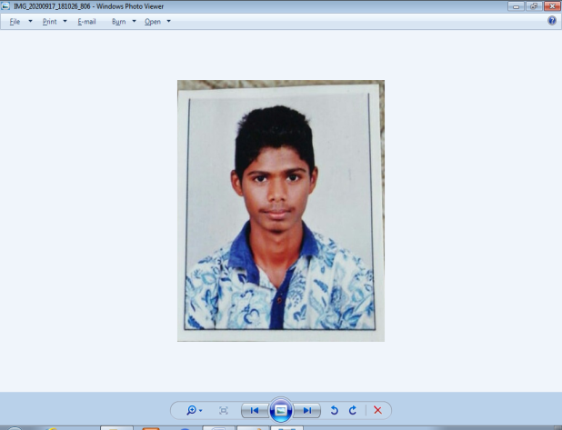

**Address** : Molahalli ,

Molahalli post, 576222

Kundapur Taluk,

Udupi District

**Ph. No** : 9611855908

**Email** : [**ashok1402.gfgcb.bca17@gmail.com**](mailto:ashok1402.gfgcb.bca17@gmail.com)

|  |
| --- |
| CAREER OBJECTIVES |

To work in a challenging environment that provides opportunities for learning and growth.

EDUCATION

|  |  |  |  |
| --- | --- | --- | --- |
| **Qualification** | **Board/University** | **Year of passing** | **Percentage** |
| BCA | Mangalore University | 2020 | 64.93% |
| PUC | Department of Pre –University Education Board | 2017 | 59.5% |
| SSLC | Karnataka Secondary Education Board | 2015 | 73.76% |

SOFTWARE SKILLS

* Languages : C , C++ , Java ,HTML , VB.Net ,PHP.
* Operating system : Windows , Linux
* Database : Oracle (SQL),MS Access
* Other skills : MS Word ,MS Excel , MS Power point.

PERSONAL SKILLS

* Have a good communication skill.
* Willingness to learn.
* Have a friendly nature.
* Easily mingle with the people.
* Self-motivated.

TRAINING AND CERTIFICATIONS

* Participated in ABC Technologies training.
* Participated in Nitte IT Fest.
* Attended two days training on Python programming Language.

AWARD AND RECOGNITION

* Participated with the Dharmasthala foundation in doing Yoga for the Guinness world record.

INTERESTS AND EXTRACURRICULAR ACTIVITIES

* Participated in cultural activities**.**
* **NSS**

PERSONAL INFORMATION

**Father Name** : K Narayana Kulal

**Date of Birth** : 13 February 2000

**Language** : English, Hindi and Kannada

**Hobbies** : Reading Story Book ,Playing games.

Declaration: I hereby declare that the above written particulars are best of my knowledge and belief.

**Date** :17-09-2020

**Place** : Molahalli

Your’s sincerely,

(Ashoka**)**