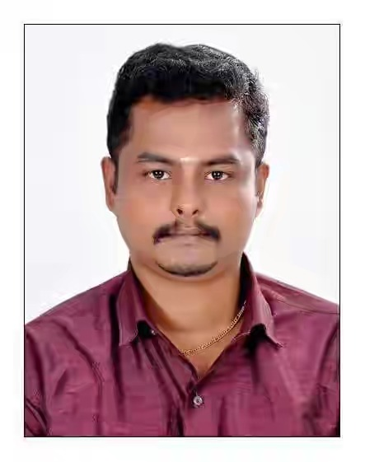
K. SARAN SELVAM

sarankirshna1988@rediffmail.com
Mobile no: 91- 9597948586, 8940901514

CAREER OBJECTIVE
- To associate myself with an organization that provides a challenging job and an opportunity to prove innovate skills and diligent work.
- Good knowledge in related operations and Good coordinate with Clients, Ability to troubleshoot and sort out the issue simply and safely.
- Exceptional liaison with global experience.

EDUCATION QUALIFICATION
Qualification | School / College | Year of Passing | Board / University | % of Marks
S.S.L.C | Govt.High.School, Eraviputhoor. | 2004 | TN State Board | 60%
HSC | Govt.Hr.Sec.School, Kumarapuram Thoppur. | 2006 | TN State Board | 65%
DEEE | Sun Institute of Technology, Erachakulam. | 2009 | State Board | 70%

WORK EXPERIENCE
- 1 ½ Years experience in Indian Restaurant for Saudi Arabia
- 3years Experience F&B serives and cashier in My own Hotel at Nagercoil

PERSONAL PROFILE
Father’s Name : Mr. C. Krishna Pillai
Date of Birth : 04.07.1988
Gender : Male
Marital Status : Single
Nationality : Indian
Languages Known : Tamil, English, Malayalam & Hindi
Address : S/o C. Krishnapillai,
4/33A, Muganthan Illam,
South Street,
Eraviputhoor & P.o,
Kanyakumari District  629 402.

Passport : Valid passport available

DECLERATION
I hereby declare that the about furnished details are true to the best of my knowledge and belief.
Regards

SARAN SELVAM. K

