CURRICULUM VITAE
Dr. Rajeevan Moothal  SANCYA School of Yoga, No.1, Thendral Nagar, Sadayandi Kuppam Road, Pallithennal, Villupuram District, Tamil Nadu. (Near Villianur, PUDUCHERRY), India. PIN: 605102.  Mobile: +91-9207345210  E-mail: seriraj@gmail.com  Skype: rajeevsai2007 | 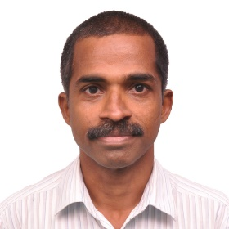 | Linkedin: https://www.linkedin.com/in/rajeevan-moothal-84818ba/  Facebook: https://www.facebook.com/rajeevan.moothal  YouTube:https://youtu.be/GrlWkADDAWc  https://youtu.be/iVeFBbFI118  Instagram: https://www.instagram.com/rajeevan2017/?hl=en
CAREER SUMMARY
Senior Yoga Manager and Yoga Instructor, Lead Yoga Teacher Trainer, Yoga Therapist and Yoga & Ayurveda Writer and Blogger, Recreation and Wellness Manager, and Personal Trainer with more than 18 years of yoga teaching, fitness training and yoga activities management and wellness management experience.
SKILLS
YOGA :Yoga Therapy, Hata Yoga, Ashtanga Yoga, Ashtanaga Vinyasa Mysore style, Kriya Yoga, Mantra Yoga, Mudra Yoga, Pre-natal (Pregnancy) Yoga, Kids Yoga, Kundalini Yoga. Expert in Spirituality, Holistic Treatment, Yoga Philosophy,YogaTheray, Pranayama and Meditation. Yoga and Ayurveda Writing, Blogging. Health and Wellness Writer with Fiverr.com
WELLNESS: Personal Wellness Trainer, Fitness Trainer, Ayurveda Diet, Nutrition, Lifestyle Management, Stress Management, Yoga Therapy for various illnesses like diabetes, High Blood Pressure, Anxiety, Depression, Addiction, Insomnia, High Sugar, High Cholesterol, Hyper Thyroidism, etc. Mindfullness Meditation with Shambavi Mahamudra and Vipasana techniques.
MANAGEMENT: Wellness Centre Management, Staff Management, Project Execution and Management, Capacity Building and management, Lifestyle Management, Personality Development and Management, Behavioural Improvement Expert, Personal Training, etc.
EDUCATION
Ph.D. Geology: Goa University, India. October 2001.
1996 to 2001

M.Sc. Marine Geology:Cochin University of Science and Technology, India. March 1995.First Class(66%).
Dec. 1992- 1995

B.Sc. Geology: Calicut University, India. March 1992. Second Class (55%)

CERTIFICATES AND TRAINING
30 August 2016: 200 RYT Yoga Alliance, USA Certification, from Yogadarshanam,
Mysore, India.Yogadarshanam is an Iyengar Teacher’s institute.
Jan - Dec 1995: Yoga Teacher Course at Kavilbhavan Yoga Center at Nileshwar, Kerala,
INDIA. Learned traditionally under a Guru(Master) and no certificates earned.

PROFESSIONAL EXPERIENCE
December 2019 to till Date: Yoga Therapist, Lead Yoga Instructor and Yoga Manager at Sri Ananthi Nature Cure and Yoga Ashram, (SANCYA www.sancya.net/about-us ), India.
- Yoga Therapist and Lead Yoga Teacher Trainer for 200 RYT Yoga Alliance USA certified courses, Teaching Yoga to the school, college and University teachers and students, Corporate staff and patients of the local Ayurvedic and Medical Hospitals.Life style management workshops and seminars.
- Recreation and Wellness Activities Design, Execution and Management,
- Wellness Counselling, Diet Management and Nutrition
- Yoga and Wellness Talent Sourcing, Aquisition, Training and Management.
September 2017 to November 2019: YOGA MANAGER AND SENIOR YOGA INSTRUCTOR
(2 years) at Sri Nithyananda Yogashrama, Kerala, India.

- Teaching Yoga to the school, college and University teachers and students, Corporate staff and patients of the local Ayurvedic and Medical Hospitals.Life style management workshops and seminars.
- Recreation and Wellness Activities Design, Execution and Management,
- Wellness Counselling, Diet Management and Nutrition.

20 JAN 2018 to 25 Feb 2018: GUEST YOGA TEACHER at NILESHWAR HERMITAGE RESORT
(1 month) Nileshwar, Kasaragod District, Kerala, INDIA. FULL TIME.

Oct. 2015 to July 2017: ASSISTANT PROFESOR and YOGA INSTRUCTOR at Adigrat
(2 years) University, Adigrat, Tigray, Ethiopia.
- Teaching Geology. Also teaching Yoga to the students, teachers and staff in association with the Sports Department.

Oct. 2010 to Aug. 2015: YOGA MANAGER and SENIOR YOGA INSTRUCTOR
(5 Years) Sri Nithyananda Yogashrama, Uppala, Kasaragod
District, Kerala, INDIA.
Oct. 2008 to July 2010: ASSISTANT PROFESOR at Mekelle University
(2 years) Mekelle, Tigray, Ethiopia.
- Teaching Geology to the B.Sc. and B.Eng. Petroleum Engineering students.

Oct. 2005 to Aug. 2008: YOGA MANAGER and SENIOR YOGA INSTRUCTOR
(3 Years) Sri Nithyananda Yogashrama, Uppala, Kasaragod
District, Kerala, INDIA.

Nov. 2004 to Aug. 2005: PROJECT MANAGER at Mubarakia Marine
(1 year) Service Company, Ahmadi, Kuwait.

Jun. 2001 to Oct. 2004: YOGA MANAGER and YOGA INSTRUCTOR at NALANADA RESORTS
(3.5 years) Nileshwar, Kasaragod District, Kerala, INDIA.

WELLNESS CAMP COUNESLOR, YOGA TEACHER/ TRAINING COURSES ATTENDED
- Yoga Teacher Training course: Conducted 200 Hrs Yoga Teacher training in 2016-2017 and since 2019 December to till date.
- Yoga Rereats at Nileshwar, Kerala, India: 30 Yoga Retreats between 2004 to 2014
- Workshops on Life Style Management through Yoga Therapy, Pranayama and Meditation, Nalanda Resorts, India, 2010-2014
- Athletics and Sports Coach: As a Coach for Sports and Games like Football, Cricket and Table Tennis and Athletics in a three months Student camp held at Kasaragod, India between April to June 1994 -1998.
YOGA, AYURVEDA, HEALTH AND WELLNESS PUBLICATIONS: Most Recent Blogs only
- https://yogurveda.com/guide-to-heal-insomnia-through-yogic-ayurvedic-approach/
- https://yogurveda.com/guide-to-heal-insomnia-through-yogic-ayurvedic-approach/
5 Star Reviews in Fiverr.com: https://www.fiverr.com/rajeevan2007/write-yoga-health-and-wellness-article-or-blog
AWARDS/FELLOWSHIPS__________________________________________________
- Best Yoga Teacher Trainer, August 2016 batch, yoga Teacher Course at Yogadarshanam, Mysore, India
2. MILEN International Conference Grant, University of Oslo, Norway, November 2010.
PERSONAL DATA________________________________________________________
1. NAME AND DATE OF BIRTH: RAJEEVAN MOOTHAL. 27-05-1972.
2. PERMANENT ADDRESS: Near petrol Pump, Karuvacherry, Nileshwar (P.O), Kasaragod
(Dt.), Kerala, 671314, INDIA.
3. MARITAL STATUS: Single, Never married, Male 4. NATIONALITY: Indian
5. HOBBIES: Yoga and Ayurveda Writing & Blogging, Wellness Counselling, Playing Cricket, Football, and Table-Tennis.
I declare that all the details furnished above are true to the best of my knowledge and belief.
Rajeevan Moothal

Yoga Master and Life Management Coach: Dr.RajeevanMoothal: Yogasana images
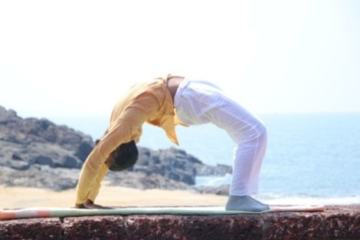  Chakrasana | 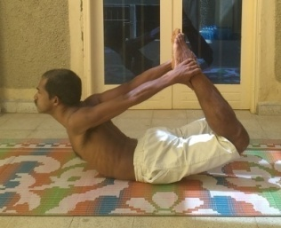  Dhanurasana | 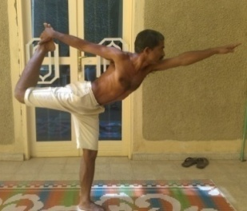  Natarajasana
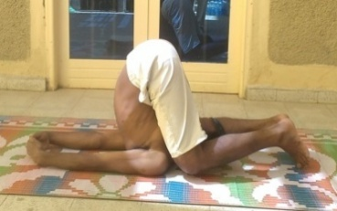  Karnapitasana | 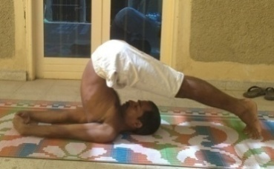  Halasana | 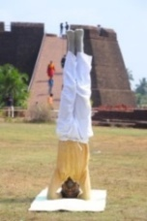  Seershasana

