

***RISHABH***

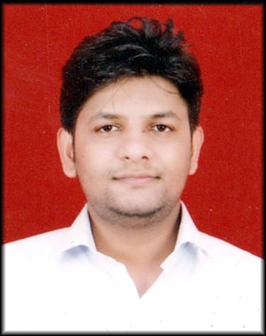

***Permanent Address:***

***H.No.:-F-48RadheyPuri NewDelhi-110051***

***Mobile:+91-9718977794***

***E-Mail:- rishabh32142@gmail.com***

***PersonalData:***

***DateofBirth :21****st****,NOV,1995***

***Maritalstatus :SINGLE***

***Father’s Name: Sh. SUKHBIR SINGH***

***Nationality :Indian***

***Languages :English,Hindi***

***Hobbies :Music,Cooking, AdventureTraveling***

***RESUME***

***WorkObjective***

***To work in competitive and challenging environment to contributing the growth of organization through constant learning and innovation.***

***Experience***

***Hotel Receptionist,November 2014-March, 2020***

*HotelYork,ConnaughtPlace,Delhi.*

Operation manager

The indigo stay,April,2019-Present

***Responsibility***

* *Welcome and greet guests with great courtesy*
* *Manage room reservations using a computerized reservations system*
* *Address guests concerns and special requests in a professional and personal manner*
* *Ensure that guests are settled comfortably in their rooms, makes necessary adjustments if needed*
* *Help guests with their things including luggage and other valuables*
* *Get transport for customers*
* *Answer telephone ca****ll****s and transfers these to guest rooms*
* *Prepare bi****l****ls ,handle and process checkouts ,take payments*
* *Communicate with housekeeping and maintenance staff to ensure that great quality service is provided to guests*

***Strengths***

* *Having good trait of being punctual.*
* *Proficiency in Microsoft Word , Excel , and PowerPoint*
* *Friendly and outgoing personality*
* *Formal training in hotel service*
* *Good knowledge of Computer hardware softwareand Networking*
* *Comfortably handle any situations*
* *Having ski****l****ls of learning new things quickly.*

***EducationalQualification***

* *SecondarySchoolExaminationfromCBSE,Delhi.*
* *HigherSecondaryExaminationfromCBSE,Delhi.*

* *GRADUATED,DUSOL,Delhi*

***Assets***

* ***Good understanding of human Behavior.***
* ***Keen desire to achieve Success, Self Discipline.***
* ***Good planning skills, believe only in results.***
* ***Spirit of team work and cooperation.***

***Declaration***

***I solemnly declare that the above information is true and correct to the best of my knowledge. I understand that if any information given above is found false/incorrect, my candidature is liable to be rejected.***

***__________________***

***Date:*** ***Signature***

***Place:NewDelhi***