**RESUME**

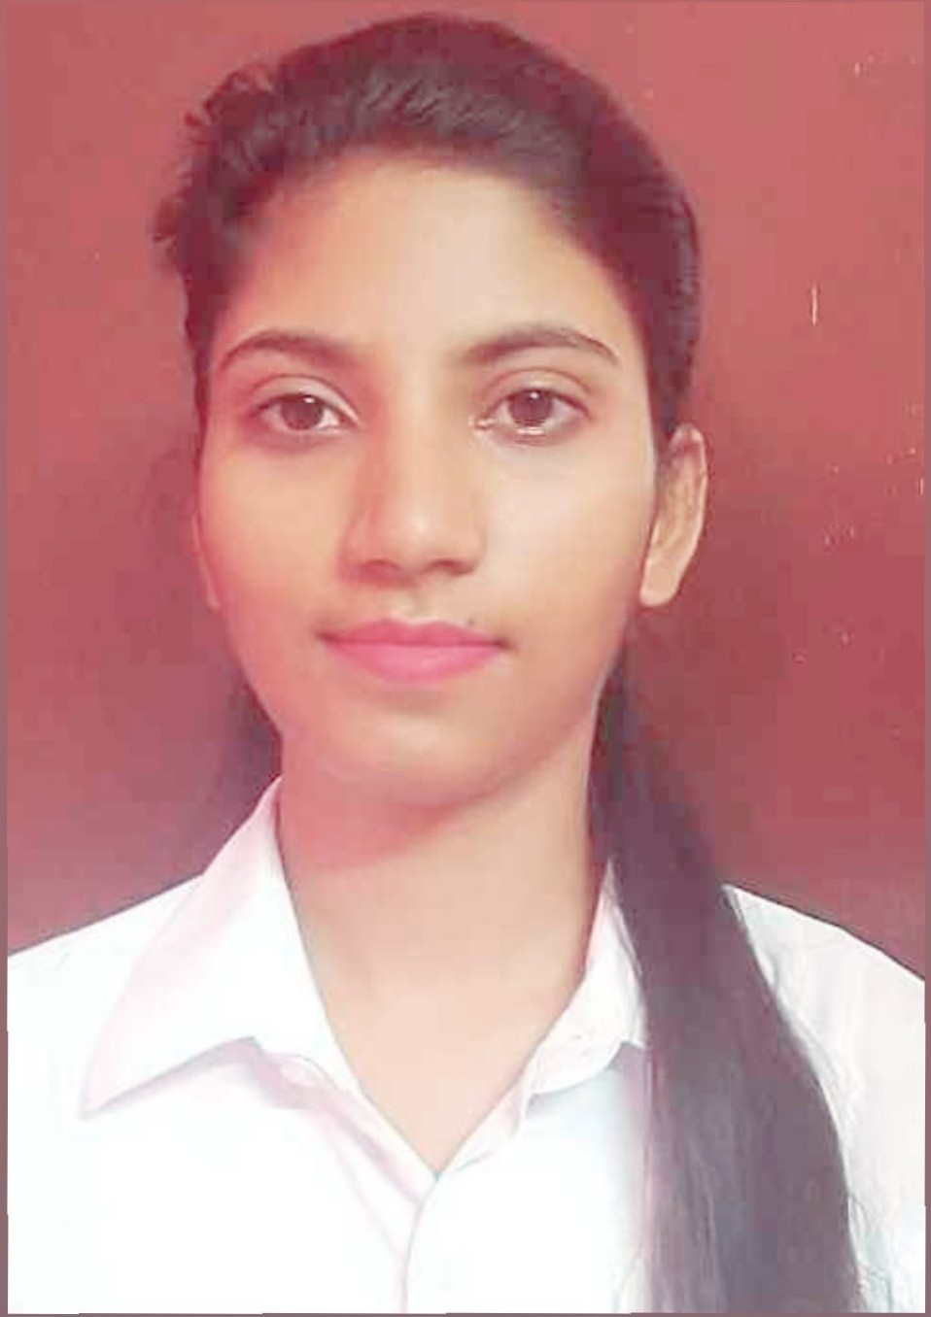

**PUJA YADAV**

**Mobile**: +91 9832933902

**Email**: [yadavpuja0408@gmail.com](mailto:yadavpuja0408@gmail.com)

**Career Objectives:**

To work in a profitable and progressive organization where I can enhance my skills and learning in order to contribute to the success of the organization as well as to grow further professionally.

**Skills:**

* Highly motivated and eager to learn new things.
* Strong motivation and leadership skills.
* Ability to work under pressure.
* Good Team Player.
* Good in MS Office ( Word, PowerPoint, Excel )

**Academic Qualifications:**

|  |  |  |  |  |
| --- | --- | --- | --- | --- |
| **Examination** | **Institution** | **Board** | **Marks (%)** | **Year Of Passing** |
| Pursuing MBA | Siliguri Institute of Technology | MAKAUT |  | 2021 |
| B.Com Management Honours | Salesian College Siliguri Campus | North Bengal University | 52% | 2017 |
| 10+2 | Himalayan English School | ISC | 76.26% | 2014 |
| 10 | Himalayan English School | ICSE | 72% | 2012 |

**Internship:**

Done 2 months internship in Bank of Baroda

**Certification:**

* Fundamental of Digital Marketing – from Google Digital Unlocked
* Global Marketing Management – from Swayam - NPTEL
* Financial Accounting – from Swayam - NPTEL

**Hobbies:**

* Reading
* Travelling
* Listening Music
* Cooking
* Gardening

**Personal Details:**

Name: Puja Yadav

Father’s Name: Sagar Bali Yadav

Mother’s Name: Seema Yadav

Date of Birth: 8th April, 1995

Nationality: Indian

Gender: Female

Blood Group: AB+

Marital Status: Single

Languages Known: Hindi, English, Bengali, Bhojpuri

Permanent Address: 2no. Jyoti Nagar, Iskcon Mandir Road, Siliguri. Dist- Jalpaiguri,

Place: Siliguri

Pin Code: 734001

State: West Bengal