**RESUME**

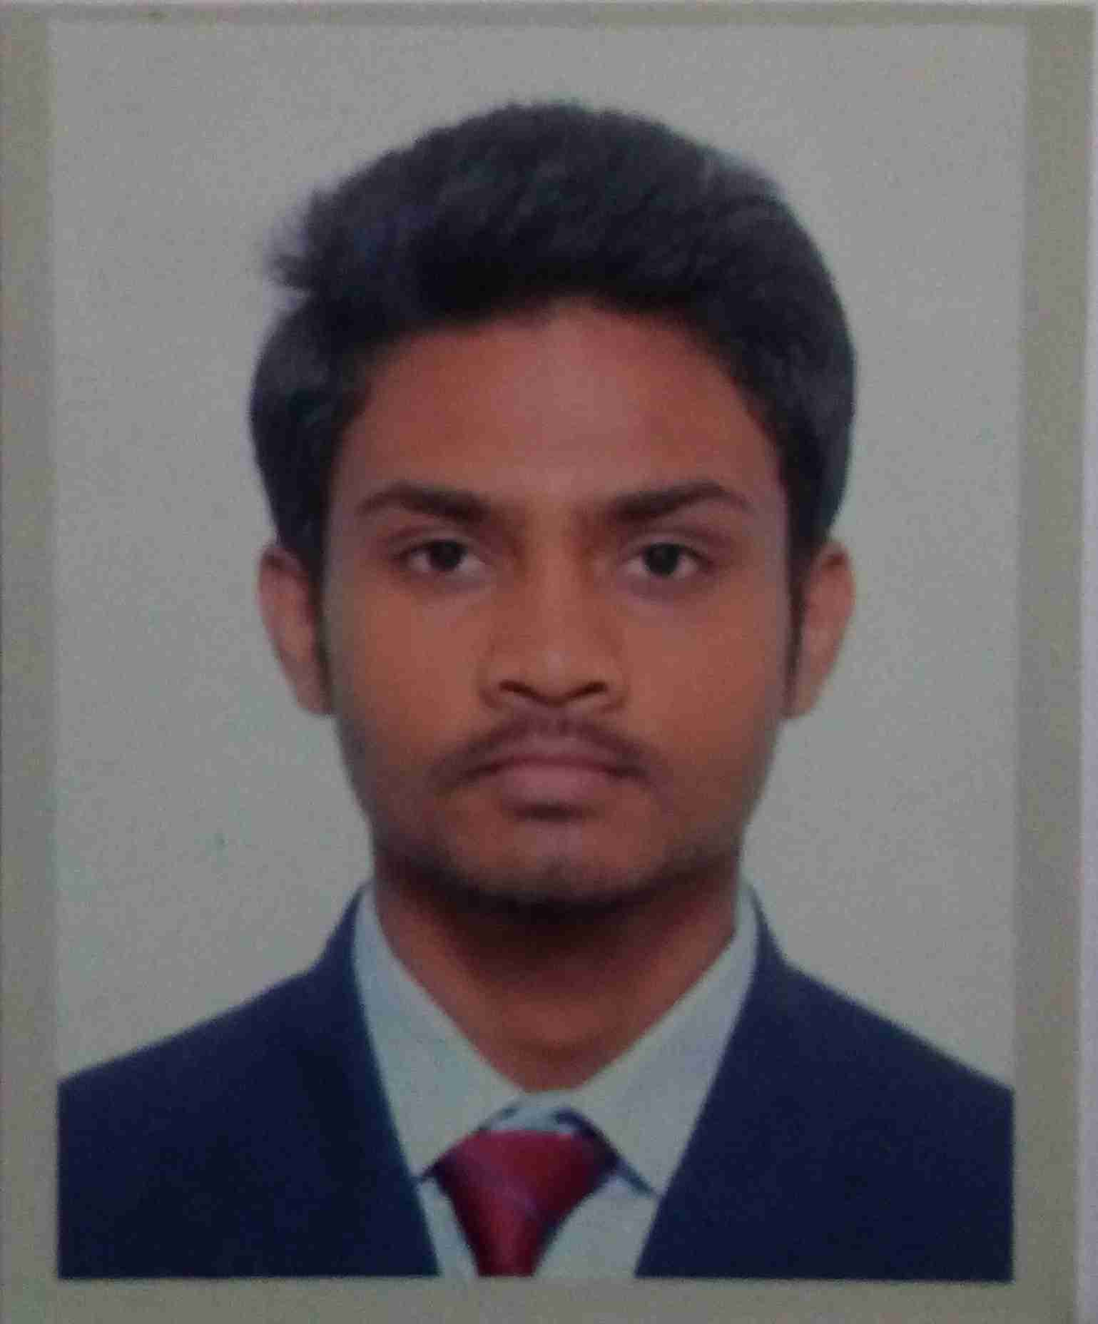

**CAREER OBJECTIVE:**

To build my career under organization that helps to grow professional skills and would lead me for a better carreer with every step and to obtain a rewarded career with an opportunity for personal growth and advancement.

**ACADEMIC PERFORMANCE:**

* + **Bachelor of Engineering Degree** in **Mechanical Branch** from **CHHATRAPATI SHIVAJI INSTITUTE OF TECHNOLOGY** with **72.40%** aggregate IN 2020.

**HITESH NEWARE**

Hiteshneware247@gmail.com

9926753871

* + **12TH** from **B.S.P S.S.SCHOOL, SECTOR-7, BHILAI**(CBSE Board) with **66%** in 2016.
  + **10TH** from **B.S.P S.S.SCHOOL SECTOR-7, BHILAI** (CBSE Board) with **55%** in 2014.

**MINOR PROJECT:**

**Project Title** : All Terrain Security Vehicle(Hovercraft).

**Summary** : Study and Design of Hovercraft along with its fabrication

**VOCATIONAL TRAINING:**

**Sixth Semester**

Organization : **South East Central Railway, Raipur**

Summary : Gain practical knowledge of **Wagon Repair And Maintenance**.

**Fourth Semester**

Organization: **BOSCH**

Summary : Gain practical knowledge about the complete process of **Car Air Conditioning System, Auto Electrical System, Bosch Automotive Battery.**

**SKILLS:**

**Technical :** Creo, AutoCAD, C++, Java

**Professional** : Adaptive nature, Consistency, Positive thinker, Fast Learner.

**ACHIVEMENT:**

* **1st Prize** in **Gully Cricket** in **LAQSHAY’18** held in college**.**
* **3rd position** in **Academic** competition in Senior Secondary School.

**EXTRA CO-CURRICULAR:**

* Participated in Workshop on **Basic manual Robotics And Combat Robotics** held in college.
* **NPTEL Certificaton** for Completeing the Course in **Introduction In Remote Sensing.**
* Participated in **NCC CAMP** in Class 10th held in **Disha College, Raipur**.

**PERSONAL DETAILS:**

Date of Birth : 24th July 1998

Father’s Name : Mr. Devram Neware

Mother’s Name : Mrs. Pustkala Neware

Permanent Address : 58/G, Risali Sector, Bhilai (C.G.)

Languages Known : Hindi, English

**DECLARATION:**

*I, do, hereby declare that the information provided by me, is correct and true to best of my knowledge.*

**Place: BHILAI(C.G.) Hitesh Neware**