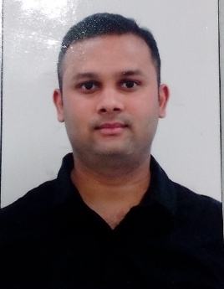

PRASHANT RAWAT

MOBILE NO: 9891942923

EMAIL ID: cestprash2305@gmail.com

Career Objective**:**

To become an integral part of your organisation by contributing profitably and qualitatively.

Personal Profile:

Working as a **Security Executive** at **Spice jet Airlines** I am now ready to take on new responsibilities to further my professional career.

My key strengths include strong eye for detail, communication and interpersonal skills. I enjoy working in a team and help others progress. At the same time I work well independently. As a highly motivated and

Driven individual I strive on taking up challenges.

**Employment History:**

1. **Presently working with Indigo Airlines as a Security Executive from Nov 2018 till now.**
2. **Worked with Spice jet Airlines as a Security Executive from Oct 2016 till 2018 October. Basic AVSEC qualified from BCAS and Dangerous Good CAT-12 Qualified from DGCA.**
3. **Kempinski Ambience Hotel, New Delhi**

**Worked as a Sr. Food & Beverage Assistant, from November 2012 till 2014.**

1. **Trident Hotel Agra**

**Worked as a Food & Beverage Assistant, from October 2011 till 2012.**

**4. Jaypee Hotels Agra**

**Worked as a Food & Beverage Assistant, from August 2010 till 2011**

**Professional Education**:

**Date:** JULY 2008 – JUNE 2010

**Name and Address of the Institution**: Institute of Hotel

Management and Catering Technology, Jammu & Kashmir India

Principal Subjects: Food production management, Food & Beverage service operations, Hotel Management, Hotel marketing, Computer applications, Hotel accounting, Catering management, Front office operation, Rooms division management, Human resources management.

Title of the Qualification awarded: Three Years Degree in Hospitality and Hotel Administration.

**Organization Skills:**

* Ability to apply relevant information, regulations, operation to provide and maintain positive guest service.
* Able to perform in various business situations including solving guest complaints and other work related problems.
* Leadership skills are attained through guest and staff interaction, staff management, and team planning and policy administration

**PERSONAL PROFILE**

* **Date of Birth**: 20th Nov 1989
* **Nationality**: Indian
* **Marital status**: Single
* **Father’s Name**: Mr.Sunil Kumar Rawat
* **Languages**: English, Hindi, Punjabi
* **Education level**: Bachelor’s degree
* **Current location**: New Delhi, India
* **Hobbies**: Playing football, listening to Music

**PRASHANT RAWAT**