SAIKAT ALLEY BISWAS
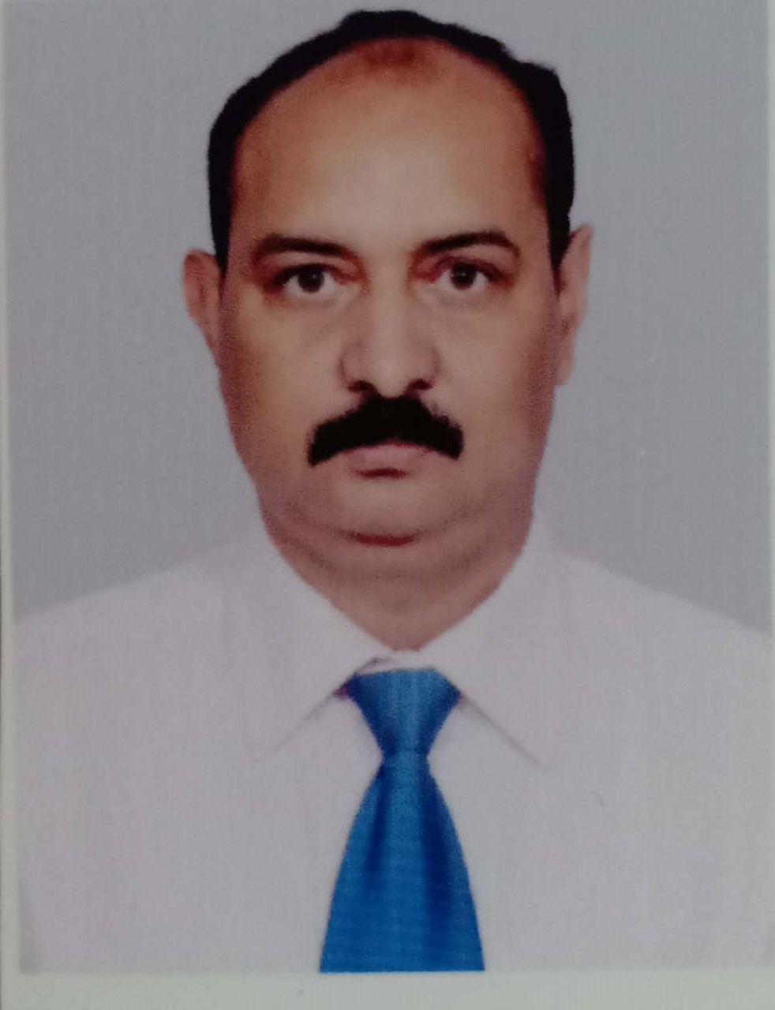

E-Mail: sabs09@rediffmail.com; saikat.a.biswas@gmail.com

Mobile: +91-9832000009, +91-9748738599, +91-9883019546

JOB OBJECTIVE
Client Management | Vendor Management | Service Operation
Telecommunication Industry

SNAPSHOT
- Innovative, diligent, and results-driven professional, with over 2 decades of experience in telecommunication sector. Previously associated with Harmony for Silver Foundation as Event Coordinator.
- Self-motivated professional offering easily transferable skills and extensive experience in customer service and client relations management.
- Equipped with dedication to superior service and track record of success in attaining customer satisfaction.
- Accustomed to developing effective client relations and ensuring total customer satisfaction. Represent the organization at various Consumers Grievances office for redressal.
- Possess proven record of success in leading technology initiatives and streamlining existing business operations to establish collaboration with business leaders / government bodies and presenting solutions with a compelling ROI.
- Consistently recognized for superior performance and creative problem-solving abilities. Demonstrate in-depth knowledge of business and operations processes.
- Strong leadership skills, lead cross-functional teams in delivering strategic initiatives proven to improve systems, processes and bottom-line results.

COMPETENCY COVERS
Strategic Planning Operations Management Process Improvement
Service Quality Regulatory Compliance Vendor Management
Telecom Audits Key Account Management People Development & Training

CAREER CONTOUR
R B Buildcon Consultant Sep’18 – Till Date
- Spearhead the activity of taking Projects from L & T Construction.
- Made all arrangements for Labour force and all relevant activities for the enrolment of the manpower at L&T worksite
  - Execution of civil works at L & T site as per the specifications and layouts provided
  - All administrative works for the Organisation & L&T
- Ensure that all safety parameters are adhered to at the worksite at all times to arrest any damage.
- Completed 3 projects for L&T – NEIGHRIMS Shillong, Diamond Harbour Medical College & ITC –MXD Rajarhat

Harmony for Silvers Foundation Event Coordinator Nov’17 - Jan’19
- Spearheaded end to end execution and co-ordinated with Main Event Organiser (ProCam).
- Served as the primary point of contact in:
  - Finalising vendors for Bus / Car / Manpower, etc.
  - Liaising with various Clubs within Kolkata & surroundings.
- Performed administrative tasks which includes enrollments of participants & need analysis for better event management

Reliance Communications Ltd. Apr’08 - Oct’17

Back Office & TRAI Head - Kolkata & Bengal Nov’13 to Oct’17
- Rendered efficient service in managing RCA / RCF for all critical issue raised from Kolkata & Bengal Circle; successfully handled UAT of new products & services / utilities.
- Expedited orders by ensuring adherence to DOT / TRAI / Regulatory Compliance; represented the organization to all Govt. Departments.
- Monitored and coordinated timely resolutions of all the escalations raised by Retailers & Distributors from Kolkata & Bengal.
- Conducted CAG workshop under TRAI. Led all initiatives in Nodal / Appellate / Call Center/ ROR /SR management.

Circle Training & Escalation Head – Kolkata Nov’12-Oct’13
- Managed RCA / RCF for critical issue being faced for Kolkata Circle; successfully handled UAT of new products & services / utilities.
- Ensured adherence to DOT / TRAI / Regulatory Compliance; conducted Audits for Call Center, Self Care, Website Product & Services.
- Managed all network related issues / escalations & follow ups; co-ordinated with O&M vendor & all Handset ASCs.
- Successfully handled escalations from Retailer & Distributors located across Kolkata.
- Conducted CAG workshop under TRAI; knowledge enhancement programs for Kolkata Circle.
- Carried out Nodal / Appellate / Call Center/ ROR SR management.

Circle API Head (Both CDMA & GSM) Apr’11 to Oct’12
- Established and trained skilled team for quality service delivery.
- Worked towards increasing the number of customer acquisitions and revenue market share in Postpaid / Prepaid / Hello / Mobile/Data card across the Circle (GSM + CDMA) through Acquisition Process.
- Managed Franchisees, Contact Centre and Backend team for Trouble Ticket Closures.
- Was accountable for new CAF management process being implemented across for prepaid distributors through vendors.
- Effectively liaison with Sales Team in realizing First 3 bills post Onboarding. Collection % being at 96% of total revenue.
- Functioned as an in-charge of Siliguri & Malda Cluster; collection increased from 88% to 99% within a span of 3 months.

Cluster CS Head North Kolkata(Both CDMA & GSM) Jan’10 to Mar’11
- Looked after the North Kolkata region and ensured smooth service deliveries. Collaborated with Sales, Marketing, Network, IT, Legal, Commercial, Finance and functions within CSD.
- Provided client servicing to high value, VIP, MDU & Institutional clients.
- Handled the collection case of 3.5 Crores for the cluster with an average collection performance of 98%. Managed to collect 75% of outstanding debt.
- Introduced various contest & prizes for channel partners.
- Ensured timely resolution of customer grievances.
- Worked towards enhancing the process and reducing customer complaints. Communicated processes and policies to the cluster team members.
- Involved the Channel Partners in Customer Engagement Activity across the cluster for Retention / MNP Defend activity & drive sales through referral selling / lead generation for 3G launch.
- Introduced handset repair camps across the upcountry location for the cluster to arrest churn & build customer confidence.
- Organised Training on New Model for Service Delivery Managers both Front end and back end
- Recognized for improving the collection performance : Closed the YTD 2010-2011 at 98.26%; improvement in Churn performance : Closed the YTD 2010-2011 at 1.9%

Manager - Back-end Operations Lead Apr’08 to Dec’09
- Pivotal role in
  - Introducing -
    - Process for on boarding for both Post Paid customers after Sales Acquisition; implemented better on-boarding experience for Smart GSM Customers
    - Collection from customer pickup points for brand building, customer satisfaction & reduced bad debts through collection agency.
    - Pre bill & post bill checking system for Smart GSM customer to minimize customer issues to enhance the Brand Image.
  - Streamlining the Barring & Unbarring Process (manual activity)
- Monitored Customer Usage & Payment patterns to establishing a robust credit management process with the intention of giving right service to the right customer
- Ensured adherence to DOT/ TRAI / TERM compliance.
- Managed entire End To End CAF Management for both Prepaid & Postpaid through in-house & vendor teams.
- Handled reconciliation of PostPaid Accounts to arrest any revenue leakage.
- Achieved yearly collection of 99.67%.

Dishnet Wireless Ltd. (Aircel) Customer Services - Head Bihar & Jharkhand Jan’07-Mar’08
- Headed Customer Service profile; appointed address verification agency, collection of CAF & Audit at Aircel Office for control on AV Agency.
- Ensured timely upload of customer profile in billing system; defined and implemented various processes for retention on bucket wise churn management & grace management.
- Collaborated with channel partners for maximizing effectiveness in retention at Pre Grace Callouts to arrest customers entering Grace.
- Initiated and implemented E- Recharge process for Bihar & Jharkhand; introduced Dealer Helpline for E – Recharge Retailers / Distributors.

Reliance Telecom Ltd. Customer Service Head -Jharkhand Jan'97 – Dec’06
- Accountable for attending and monitoring receivables from churn bucket in New City / Town Launch for Jharkhand.
- Recruited skilled candidates for Reliance Telecom Ltd. & the Service Providers in Jharkhand.
- Handled Credit Control for All Postpaid Customers of Jharkhand for Post Bill generation checking.
- Successfully launched Mobile services in Bihar & Jharkhand territory.
- Instrumental in decreasing the exposure to 0.0% since 2004; increasing the sales figure by reference selling in the corporates by proper liaising.
- Registered 25 % growth in voice based value added services.
- Increased revenue from SMS based service by Rs 2 lakh every month.
- Played a stellar role and achieved highest incentive in Jharkhand for the year 2004-2005.

PREVIOUS ASSIGNMENTS
Sterling Holiday Resorts (I) Ltd. Executive Customer Care Mar'95 - Jan'97
- Streamlined the holiday confirmation process for availability of Resort bookings to Customers of South Bihar (Jharkhand).
- Achieved net collection worth Rs. 34 Lakhs in a short time period of 5 months.

Gopal Agencies Part-time Supervisor Mar’93 – Mar’95

PROFESSIONAL COURSES
- Advance Customer Service Training by Team Productivity Consultants Ltd., Bangalore.
- Workshop on Customer Care by Upgrade Management Services.
- MS Windows by NIIT, Patna.

TRAINING ON
- On Putting People First by Times Management Institute.
- MDP training at IMT Ghaziabad: Effective Communication
- CP-002 for Non-Technical Members by Motorola.
- Handset Training:By Motorola, Ericsson and Philips
- Achieving Customer Delight by Dr. Mohan Agawal, XLRI, Jamshedpur.

EDUCATION
- Executive MBA Programme from MAHE 2008
- PGD in Business Administration from Indian Institute of Forest, Computers& Management, Ranchi 1999
- PG Diploma in Computer Applications from Brilliant Computer Center, Ranchi 1994
- B.Sc. – Zoology (Hons.) from St. Xavier's College, Ranchi 1994

ACHIEVEMENTS
- Awarded 2 times Best Safety Supervisor by L & T Constructions
- 6 Times VOOST Champ for the Eastern Hub at Reliance Communication Ltd
- I was nominated for MDP Programme at IMT Ghaziabad at Dishnet Wireless Ltd
- I was given cash incentives for the additional revenue stream promotion for the Circle at Reliance Telecom ltd

PERSONAL DETAILS
Date of Birth : 6th September, 1971
Languages : English, Hindi and Bengali
Permanent Address : Flat No.- 3D Block C Sagar Jyoti Apartment, R-AA/37 Raghunathpur Kolkata - 700059. India
Passport No : P 0667083; Expiry Date : 07/08/2026

