**BUBAI DAS** 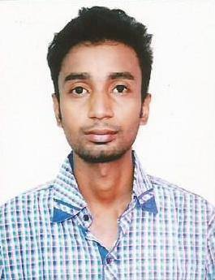

**Address:** P-93 jubilee park, Sarsuna, Kolkata-700061

**Contact:** 8910484162/8981508056

**Email:** [bubaidas8981@gmail.com](mailto:bubaidas8981@gmail.com)

**Date of birth:** 17/07/1994

CAREER OBJECT: To contribute to the growth of the company through the application of many knowledge skill and Innovating thinking.

EDUCATION:

|  |  |  |  |  |
| --- | --- | --- | --- | --- |
| **Qualification** | **Name of the institute** | **Board** | **Marks** | **Year of passing** |
| Diploma in Electronics & Telecommunication | Pailan Technical Campus | W.B.S.C.T.V.E.S.D | 75% | 2017 |
| Higher Secondary Education | Behala High School | W.B.C.H.S.E | 45% | 2014 |
| Secondary Education | Behala High School | W.B.B.S.E | 63% | 2011 |

TRANING:

|  |  |
| --- | --- |
| **Name of the Training** | **Name of the Organization** |
| Network & Telecommunication | Prasar Bharati |

PROJECT:

Laser torch based voice transmitting & receive

COMPUTER SKILLS

* Ms word
* Ms excel
* Ms access
* Ms PowerPoint
* Hardware
* Networking

WORK EXPERIENCE:

* Teacher in charge in Youth computer training Academy (1 year)
* Work in Punjab Communication Limited(Installation, Commissioning, Testing, Programming)(All India Railway Project) (2 year)

SUBJECT OF INTEREST:

* Analog Electronics & Computer network

HOBBIES & INTEREST:

Playing Cricket & Social Networking