RADHAKRISHNAN KORNENGATTIL



rdkrish86@gmail.com 8129127856

Kornengattil (H) Chethallur Mann arkkad Palakkad (Dist) Kerala (St ate) India (Country) 678583 (PI N)

SKILLS

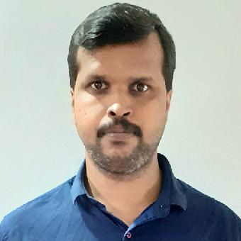

MS Word

MS Excel

PowerPoint

C, C++, VB

Languages (English, Malayalam, Hindi)

Photo editing

Internet



PERSONAL DETAILS

|  |  |  |
| --- | --- | --- |
| Date of Birth | : | 23.07.1986 |
| Marital Status : | | Married |
| Nationality | : | Indian |



INTERESTS Reading Internet



OBJECTIVE



Graduate teacher looking for a position at Higher secondary school, where I can apply my ten years of teaching experience and my curriculum development skills.



EXPERIENCE



Ministry of Education, Maldives

Graduate teacher (A level February 2012 - November 2019 and O level Physics)

Worked as a Graduate teacher in an international

●

school under Ministry of education in Maldives.

Taught Physics in Advanced level as well as

●

Ordinary level

Produced A report in both A level and O level

●

Kerala English Medium School, Odisha

Graduate Teacher June 2011 - December 2011 Worked as a graduate teacher in Higher

●

Secondary level

Taught Physics, Chemistry and Maths

●

MES KALLADI COLLEGE June 2010 - February 2011

Guest Lecturer

Worked as a Guest lecturer in Physics

* Taught Physics for both MSc and BSc students

EDUCATION



|  |  |
| --- | --- |
| FMHS Karinkallathani | 2002 |
| SSLC |  |
| 93% |  |
| MES HSS | 2004 |
| PLUS TWO (Science) |  |
| 84% |  |
| UNIVERSITY OF CALICUT | 2007 |
| BSc (Physics) |  |
| 88% |  |
| UNIVERSITY OF CALICUT | 2009 |
| MSc (Physics) |  |
| 76% |  |



RADHAKRISHNAN KORNENGATTIL