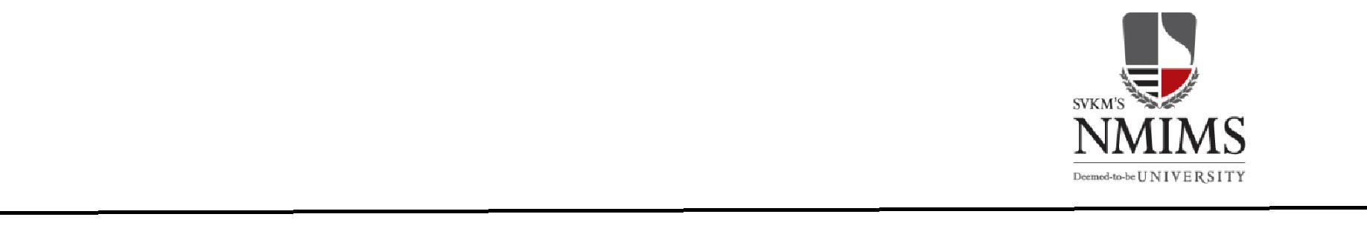**Bhavya Dubey**

**B.Tech Information Technology Engineering**

**Date of Birth:14th October 1998**

|  |  |
| --- | --- |
| **OBJECTIVE** |  |

In search of an excellent opportunity to challenge myself in a position in Computer Science offering responsibility and opportunities which can help me to grow and advance while continuously learning .Believes in working hard and giving 100% without giving up.

|  |  |
| --- | --- |
| **EDUCATION** |  |

|  |  |  |  |  |
| --- | --- | --- | --- | --- |
| **Degree** | **Institute** | **Board / University** | **Year** | **Performance** |
| **B.Tech** | MPSTME | NMIMS | Pursuing | 2.99/4.0(6th Sem.) |
|  |  |  |  |  |
| **XII** | St.Mary’s school , Harda | CBSE | 2016 | 57.8% |
|  |  |  |  |  |
| **X** | St.Mary’s school , Harda | CBSE | 2014 | 6.6/10 |
|  |  |  |  |  |
| **TECHNICAL SKILLS** | | | | |  |
| |  |  |  | | --- | --- | --- | | **Technical Skills** | **Proficient in** | **Familiar with** | | **Languages** | C/C++, Java(Core) | C#,Android | | **Web Designing** | HTML, ASP.NET,CSS | JavaScript, Jquery | | **Databases** | SQL Server Management Studio 2012 | MS Access, MY SQL | | **Software’s** | Turbo C ,Microsoft Office | Star UML, Android Studio, MATLAB | | **IDE** | NetBeans 7.2, Visual Studio | Microsoft office | | **OS** | Windows, Android | LINUX, UNIX. |  |  |  | | --- | --- | | **INTERNSHIP/TRAINING** |  |   **Company:** BSNL, HOSHANGABAD||| **Sector:**Networking.  **Duration:** 6 Weeks (May 4th, 2018 – June 14, 2018 )|||**Project Title:** Working of a telephone  **Brief Overview:**Learnt about how a telephone and a wirelessphone(Mobile) woks.  **Company**Interrnsala ||| **Sector:** Android App Development  **Duration:** 6 Weeks (1st September to 12th October 2018) ||| **Project Title:** Echo  **Brief Overview:**Learned to build User Interface and to add f unctionalities, in music player   |  | | --- | | **KEY PROJECTS/ PRESENTATIONS/ SEMINARS/ WORKSHOPS** |  |  |  | | --- | --- | | Echo Music Player | **Platform Used:** Android , Android Studio  **Brief Overview:**It’s an Android application that is basically a music player , which playes all types of music. | | Aditi online | **Platform Used:** Android , Andoid Studio  **Brief Overview:** Aditi online is an online order placing(cafeteria) application , can can place order in NMIMS campus | | BFS Flower shop | **Platform Used:** HTML , CSS , PHP  **Brief Overview: It is an website which orders flowers from home where you have to login into your account , select flowers for the situation , payment can be done online or cash on delivery.** | | My profile Application | **Platform Used:Android, kotlin**  **Brief Overview: It’s an application where an unknown can see my information , to contact me .** |   **Workshops: 1)** Ethical hacking workshop at IIT Bombay 2) Ethical Hacking work shop at College during Ambiora   |  |  | | --- | --- | | **EXTRA CURRICULAR ACTIVITIES** |  | | * Was class Representative in 9th standered * Worked in Public Relation during ambiora techfest  |  | | --- | | **ACHIEVEMENTS** |      * Received accolades in many creative fields, such as in Poster making, Calligraphy, singing, Flower Decoration and in various other Sports Activities and Science Exhibition. |  | | | | | |  |