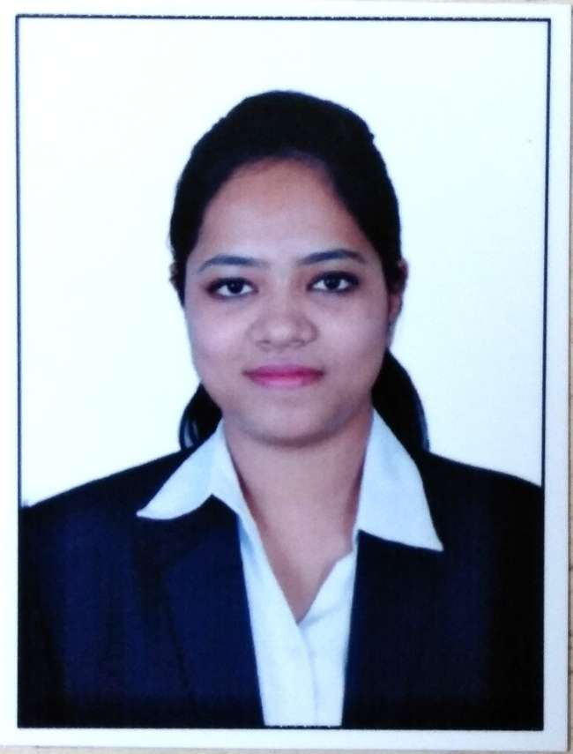

**Name:** Indrakshi Sarkar **Mobile:** 8900400703

**Email id:** [sarkar.indrakshi09@gmail.com](mailto:sarkar.indrakshi09@gmail.com)

**OBJECTIVE: ____________________________________________________________________**

* Succeed in an environment of growth and excellence. Earn a job which provides satisfaction and development.
* To obtain professional heights, through enhanced productivity, problem solving skill, knowledge and constant learning.
* To work in an environment which encourages me to succeed and grow professionally where I can utilize my skills and knowledge appropriately.

**ACADEMIC QUALIFICATION: ____________________________________________**

|  |  |  |  |  |
| --- | --- | --- | --- | --- |
| **Year** | **Examination** | **Institute** | **Board/University** | **CGPA/%** |
| 2017-2019 | MBA  Major: Finance  Minor: Marketing | Heritage Business School | Maulana Abdul Kalam Azad University of Technology | 7.28 |
| 2014-2017 | B.Com(Honours) | Sivnath Sashtri College | Calcutta University | 46% |
| 2014 | ISC | Loreto Convent Asansol | CISCE | 82.5% |
| 2012 | ISCE | Loreto Convent Asansol | CISCE | 79% |

**SUMMER INTERNSHIP PROJECT: _________________________________________**

**Kotak Securities Limited** —Summer Intern

**Internship Tenure —**15th June 2018 to 14th August 2018

**Project Name**: **Fundamental Analysis of Equity Market**

**Project summary**: Evaluating the profitability of different companies in different sectors. Estimating the next two year profit and studying the trend of the company. The study comprised of two companies of five different sectors and making a comparative study between those 10 companies. Finally studying the growth pattern, profitability and

commenting weather it is advisable to invest in the company. Investing opportunity depended on the growth movement of the company.

**Activities:__**

Business FairTopic : Entrepreneurship businessBusiness : Roadside Nursery

Carried out a survey on the day to day as well as monthly business activities ofthe business. Knowing their approximate yearly turnover and knowing about thetypes of customer they deal with. At the end making a complete report of thestudy and preparing a presentation of the entire study.

**PROFESSIONAL EXPIRENCE: ____________________________________________**

**ICICI BANK LTD –Privilege Banker**

**Tenure –**22nd May 2019 to Present

**Role:** Creating good customer base as a Relationship Manager. Bringing in business from the existing customer by cross selling products. Increasing the CASA book by bringing in funds from existing customer and also through new customer acquisition. Giving complete customer service by attending every queries raised by the customers.

**ACHIVEMENTS: _________________________________________________________**

* AMFI certified through NISM.
* IRDA certified.

**BASIC SKILLS: ___________________________________________________________**

* Basic computer skills
* MS Office, MS Excel, PowerPoint.
* Interpersonal and teamwork.
* Communication skills and experience working to deadlines.

**PERSONAL DETAILS: _____________________________________________________**

Father’s Name: Biswajit Sarkar

Mother’s Name: Debika Sarkar

Date of Birth: 09/07/1996