EDUCATION

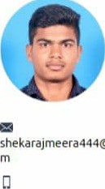

shekarajmeera444@gmail.co

# B.E

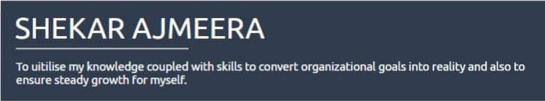Vasavi College of Engineering

|  |  |  |
| --- | --- | --- |
| 6303567025 | 07/20 • Present  Courses | 7.18 |
| SKILLS | a ELECTRONICS AND COMMUNICATION  ENGINEERING  INTERMEDIATE  Alphores Junior college |  |
|  | 20'6-20'8 | 94.8% |
| CERTIFICATES  NPTEL Certification - | Courses a MPC |  |
| digital electronics | schooling |  |
| Coursera Certification- | Kerala Model High School |  |
| Basic Python | 2016  Courses | as |
| CCNA Certification in  Computer Networks | a SSC  PROJECTS |  |
| LANGUAGES | Mobile Phone Controlled robot |  |
| English | The robot which rncvves according to the instructions We give through our android application. |  |
| Full Professional Proficiency | Remote controlled live streaming bot |  |
| Telugu  Full Professional Proficiency  Malayalam | o There is a live streaming using web camera affixed on a botwhose controlling is done by an application on the smart phone. | |
| Protesgonal Working Proficiency | INTERESTS | |

Hindi professional Working proficiency

|  |  |
| --- | --- |
| SOFT SKILLS | EXTRACIRCULAR ACTIVITI ES |



Member of Writers Club

Teamwork

Participated in Cricket tournament at VCE