**SK RAKESH HOSSAIN**

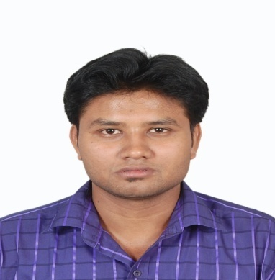



**About Me**



Hossain.rakesh33@gmail.com



+91 9903549154



August 25, 1989



5 Years experience



Kolkata, Westbengal

**C:\Users\speed1\Favorites\Desktop\rakesh copy.jpg**



**C:\Users\speed1\Favorites\Desktop\linkedin copy.png**

https://www.linkedin.com/in/sk-rakesh-hossain-480598171

**Profesional Objective**

* I am seeking a competitive and challenging environment where I can serve your organization and establish an enjoyable career for myself.
* I am seeking employment with a company where I can use my talents and skills to grow and expand the company.

**Education**



**Graduation (B.Com Honours)** Graduated, July 2011Vivekananda College Marks 43.5%  
Calcutta University Division 2  
Kolkata, Westbengal

**Higher Secendary** Graduated, April 2008Sir Nripendra Nath Institution Marks 73.5%  
WBBSE Board Division 1  
Kolkata, Westbengal

**Madhyamik** Graduated, April 2006Sir Nripendra Nath Institution Marks 71.5%  
WBBSE Board Division 1  
Kolkata, Westbengal



**Professional Qualifications and Affiliations**

**Industrial Training Institute** Graduated, July 2012Tollygunge ITI Marks 74.5%  
NCVT Board Division 1  
Kolkata, Westbengal



**Skills**

* Dedicated, disciplined and believe in teamwork.
* Committed to deadlines &

Schedules.

* Good team Player and keen Learner
* Strive for Perfection in every work.



**Work Experience**

**September, 2013 to till date**  
**Accounting**  
Srab Real Estate Pvt Ltd  
Kolkata, West Bangal  
  
**Cashier**  
Srab Real Estate Pvt Ltd  
Kolkata, West Bangal

**Assistatnt Manager**  
Srab Real Estate Pvt Ltd  
Kolkata, West Bangal



**Computer Proficiency**

* Diploma in **Financial Accounting** system in Tally
* Working Knowledge of **Excel**
* Skill edatvarious **MS Office** applications.



**Languages**

|  |  |
| --- | --- |
| * English | * Bengali |
| * Hindi |  |



**Personal Interests**

|  |  |
| --- | --- |
| * Playing Cricket & football | * Love Make new friends |
| * Spend leisure time while reading story book |  |
|  |  |



**Personal Details**

Father’s Name: Mr. Late Sk Abul Hossain Marital Status: Married  
Birthday: August 25, 1989 Nationality: Indian  
Gender: Male Aadhaar No. 503474428486

**Declaration**

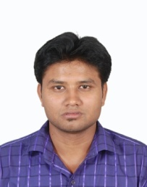I, Sk Rakesh Hossain, hereby declare that the information contained herein is true and correct to the best of my knowledge and belief.

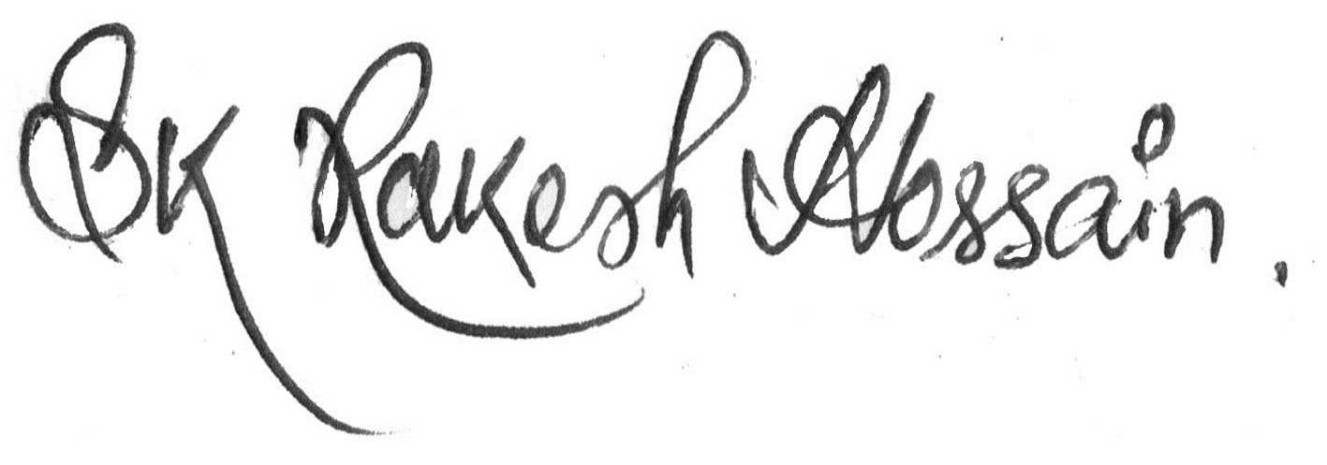

**Sk Rakesh Hossain**

Kolkata, Westbengal  
May 01, 2021