. 

Prabhaker Dutta
duttaprabhaker@gmail.com
9910940535
29C Vashudha Appartment, Sector 6, Vashundhra Ghaziabad-201012 (UP) India

PERSONAL STATEMENT

I’m an adaptable and innovative qualified person with over 10 years experiences building clients in respective.

I’m looking to develop my expertise in new areas for business development within a forward thinking company based in Delhi NCR.

KEY SKILLS

Technical Skills
- AutoCAD
- SolidWorks
- Export & Import Documentation
- Web Designing (PHP, HTML, CSS, Database, SEO SMO, Digital Branding & Promotions)
- Graphic Designing (CorelDraw, Photoshop)
- MS Office
- Tally ERP 9.0
- A+, N+

Certificates
- AutoCAD
- SolidWorks
- Web Designing
- MS Office
- A+, N+

EDUCATION

FTDC
MBA in International Business

TM Bhagalpur University
Bachelor degree in science

EMPLOYMENT

Manager- Sales and Marketing
Abhi Industrial Corporation | Noida | www.abhiindustrial.com | Jul 2012 >Till Date
Responsibilities
- Responsible for assigned sales targets (monthly, quarterly and annually).
- Developing relation with clients especially paper mills of different area of North India
- Goals set for centres month on month, maintaining relationship with target customers, customer service, ensuring high rate of return on investment, sales support and sales.
- Proper execution of order and dispatch it on time.
- Develop new sample for client.
- Branding especially Digital (Participation in Trade Expo, Branding in Alibaba, Trade India etc.)

Asst. Manager- Sales and Marketing
Allied Electronics and Magnetics Ltd | Noida |www.amkette.com | Feb 2009 > Jul 2012

Responsibilities

- Listening to customer requirements and presenting appropriately to make sales.
- Maintaining and developing relationships with existing customers in person via calls and mails
- Cold calling to arrange meetings with potential customers to prospect for new business
- Responding to incoming mails and phone queries
- Acting as a contact between a company and its existing and potential markets
- Negotiating the terms of agreement and closing sales
- Gathering market and customer information
Representing the organization at trade exhibitions, events and demonstrations
- Negotiating on price, costs, delivery and specifications with buyers and managers

PERSONAL INTERESTS

Traveling | Reading | Cricket | Foods

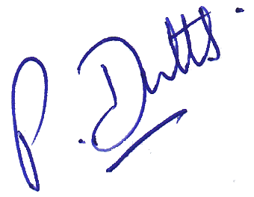
(PRABHAKER DUTTA)

