Vinay B
+91-8970894610
Vinay.vinu110@gmail.com

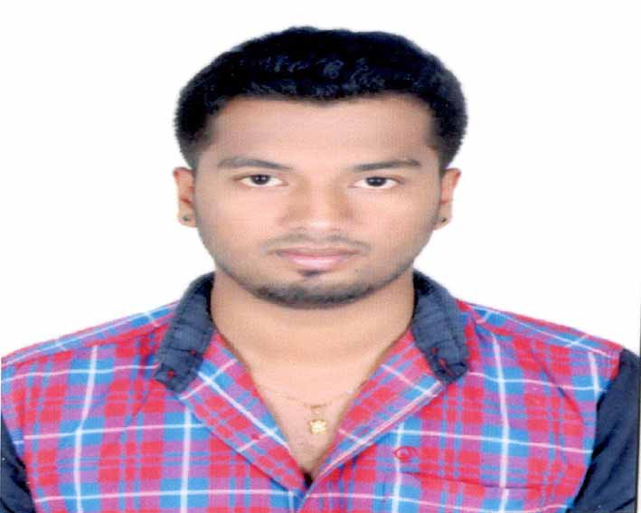

Objective
I would like to pursue my career in a work environment that will utilize and reinforce my technical and managerial skills and abilities and also to apply & gain new skills and experience in a rapidly changing field.

EXPERIENCE:
1. Worked as as a Assistant Accountant in MEGHDOOTH SUZUKI from 16-12-2016 To 31-03-2019.
2.Presently Working In SAGAR HOSPITALS as Accounts Executive From 12-04-2019
Professional Experience:
1.Managing accounts payables ,accounts receivables and payroll departments.
2.preparing annual company accounts and reports.
3.Administered online banking functions.
4.Managing vendors cheques for a credit period of 30 days.
5.Ensured compliance with accounting dead lines.
6.Entering of purchase and sales vouchers in Tally.
7.Preparation of reports for GST Filing.

Academic Credentials
Qualification | Year | Institution | University | Percentage
MBA - Finance | 2014-16 | RNSIT | VTU | 69 %
B.Com | 2014 | APS College of Commerce | BU | 64.88 %
P.U.C. | 2011 | Vijaya PU College | KSEEB | 65 %
S.S.L.C. | 2009 | Martin Luther English School | KSEEB | 82.56 %

Technical Skills
Application/Software’s | MS Office, SPSS Tool,Tally.ERP 9
Operating Systems | Windows.

Projects
MBA – Final Year | Title: A Study on Cash Management at Texport Overseas Private Limited, Bengaluru  Organisation: Texport overseas private limited, Bengaluru  Descriptions: The main objective of this project is to assess the cash levels using the financial statement of the company. This study has also determined the optimum cash balances using different Models i.e. Baumol’s and Miller & Orr Models. An analysis was made as of how well the company has maintained their cash flow w.r.t. operating, investing & financial activities.

Extra-curricular Activity
Pegasus | Participated in a three day Out Bound Learning Program titled “Self – Development through Experiential Learning” at Pegasus Institute of Excellence, Bengaluru.

Personal Information
Name | Vinay B
Date Of Birth | 23/08/1993
Languages Known | Hindi, English, Kannada, Telugu.
E-Mail | Vinay.vinu110@gmail.com
Hobbies | Playing Cricket and Listening to Music.
Permanent Address | #207,18th main ,26th cross,  poorna pragna layout,  Uttarahalli,  Bengaluru-560061.

Regards
Place: Bengaluru Vinay B

