Curriculum Vitae 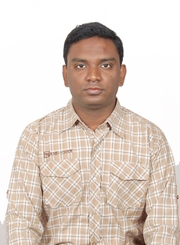

Manish
H.No.1178 B.Block
Pardesi Para Sonari
Jamshedpur – 831011
Jharkhand
Contact No.9031946353/8603851763

________________________________________________________________________

CAREER OBJECTIVE

Contribute to the success of organization with zeal and with acquired skills and continuously develop myself for becoming successful professional.

KEY STRENGTHS

- Result oriented and hard working full of commitment.
- Process sharp judgment and team player attitude.
- Flexible and adaptable nature.
EDUCATIONAL QUALIFICATION

Exam.  passed | School/College | Board/ University | Year of passing | Division
MATRIC | Kadma Boys High School,Jamshedpur | Jac,Ranchi | 2003 | 2nd
ISC | Karim City College,Jamshedpur | Jac,Ranchi | 2007 | 2nd
BSCIT | Sikkim Manipal University | Sikkim Manipal University | 2010-13 | 1st
ITI | Booty Institute Of Technology,Ranchi | Ncvt,Ranchi | 2011-13 | 1st

PROFESSIONAL SKILLS

- Software Basic Application From Aashirwad Info.Com
- BCC Course From Doeacc Society
- Bridge Course From NTTF

EXPERIENCE

- Worked as a Fitter Nagarjuna Construction,Tata Steel Ltd From January 2014 to October 2014

- Working as a Consultant From November 2014 MARKETING & SALES (QA) ISWP(sub of Tata steel Limited)

- Experienced in manufacturing of Welding Electrodes, Experienced in Quality assurance of Welding Electrodes,Mig Wires

- Experienced in Sales of Welding Electrodes,Mig Wire

PERSONAL DETAILS

Name : Manish
Father’s Name : Mr. Gangadhar Mukhi
Date of Birth : 14th November 1987
Sex : Male
Nationality : Indian
Languages known : Hindi English &Bengali
Marital Status : Married
Permanent Address : H.No.1178 B.Block Pardesi Para
Sonari, P.O.Sonari,
Jamshedpur – 831011, Jharkhand

I hereby declare that the information furnished above is true to the best of my knowledge and belief.

Date :03/09/2020

Place: Jamshedpur. (Manish)

