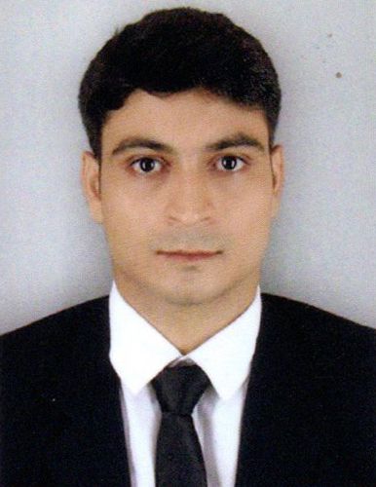

**CURRICULUM VITAE**

**PERSONAL DETAILS**



Name: GOPAL KUMAR

Date of Birth: 14-02-1994

Nationality: INDIAN

**OBJECTIVES**



To work hard with dedication and determination so as to help the organization in achieving its goal and excel Myself in the profession by obtain a whole understanding of the hotel operation through all their different departments in order to allow me to manage the operation on an effective way by providing an excellent service and creating guest for life through meaningful experiences.

**INTERNSHIP DETAILS**



Internship Program: Hospitality Internships Program

Department: RESTAURANT MANAGEMENT/Food & Beverage Service

Duration of Internship: 24 weeks

Visa: J 1

Location: 308 Watkins Lane Saint Michael MD 21663 (USA)

**ACADEMIC ACHIEVEMENTS**



**26/07/2017-26/06/2019**

**DIPLOMA IN HOTEL OPERATION**

JIS GROUP-GURU NANAK INSTITUTE OF HOTEL MANAGEMENT,KOLKATA

Website link to University:- [gnihm.ac.in](http://gnihm.ac.in/)

City:-Kolkata / Country:- India

**WORK EXPERIENCE**



05/23/2018 TO 11/21/2018

**POSITION TITLE:- MANAGEMENT TRAINEE**

**Inn At Perry Cabin By Belmond**

**308 Watkins Lane Saint Michael MD 21663 (USA)**

HOTEL/RESTAURANT STAR RATING:- 5 Star

Website link:-

<https://innatperrycabin.com>

**TRAINING PLANS**

HOST COMPANY ORIENTATION

FOOD&BEVERAGE FUNDAMENTALS

RESTAURANT OPERATIONS

BANQUET AND EVENTS

ADVANCE F&B TRAINING

**ADDITIONAL SKILLS, EXPERIENCE & AWARDS**



Completed AHA (American Hospitality Academy)

School Level Football Certificate.

Recommendation Latter of General Manager(IPC)

**COMPUTER & LANGUAGES**



Diploma in Computer Application. (DCA) 6 months.

Typing In English.

**EXTRA CURRICULAR ACTIVITIES AND HOBBIES**



Interact with peoples,Reading Books,Listening Music,

Watching Movies & Playing Footballs.

**REFERENCE**



To The Training and Placement Officer

GURU NANAK INSTITUTE OF HOTEL MANAGEMENT, KOLKATA,

WEST BENGAL, INDIA 700114

Contact Address : [arkachakraborty@jisgroup.org](mailto:arkachakraborty@jisgroup.org)

Training & Placement Officer MR. ARKA CHAKRABORTY

College contact no. : 033 2523 1246 / +91943225716

**REFERENCE**

Kathleen Uhl

Human Resource’Coordinator

The Inn At Perry Cabin Belmond

308 Watkins Lane

St.Michaels,MD 21663

**REFERENCE**

To The

MICHAEL B.HoFFMANN

GENERAL MANAGER

TThe Inn At Perry Cabin Belmond

308 Watkins Lane

St.Michaels,MD 21663

**PERSONAL DATA**



* Fathers Name :: Ram Binod Kumar
* Father’s Profession :: Ex-Service Man (CISF)
* Mother’s Name :: Hira Devi
* Mother’s Profession :: Housewife
* Date of Birth :: 14th February, 1994
* Age :: 26yrs.
* Nationality :: Indian
* Religion / Caste :: Hindu / Brahmin
* Height / Weight / Health :: 170 Cm / 55 kg / Healthy
* Email ID :: 11gopal23@gmail.com
* Mobile No :: +917061076637/7319974554

**DECLARATION**



I hereby declare that all the above mentioned data and information Shown are true to the best of my

My knowledge & believe.

Yours Faithfully

Date :

Place : GOPALKUMAR