RESUME

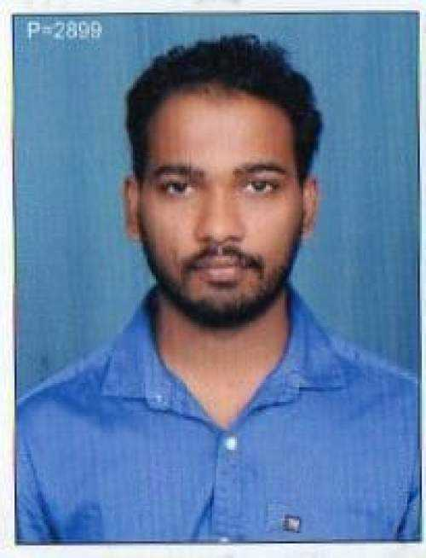
SANJAY RAMA GOUDA Email:sanjaygouda9270@gmail.com

Cell: +917483769613

Objective:
To be associated with progressive organization that gives me the scope to apply my knowledge, skills, and abilities and to involve as a part of the team that dynamically works towards the growth of the organization.
Educational Details:
- Diploma in Tool and Die Making from Govt.Tool Room and Training Centre, Karnataka,Dandeli during 2015 with 77.55 %
- 10th Std P.M High school Ankola during 2011 with 69.76%
Computer Skills:
- Completed Training and passed the final certification exam in AUTO CAD from PSMC Multi Education Dandeli with diplomate Number : AC  12/21
- Good knowledge of MS-Office Package.
- Windows 98, 2000, Windows XP
Work Experience :

- 5 Years of work experience in plastic Injuction moulding process, mould maintenance and tool room work from ALBEA Betts india Pvt Ltd Goa. Since June 2014 to Till Date.
- Knowledge of Hot Runner and semi hot system.
- Perform mould and insert changes.
- Develop and mention accurate set-up sheet and record.
- Start-up injection mould process adjustment.
- Work to mention production schedule.
- Ability to visually detect quliety defact.
- Identify maintenance and process concerns and work to assist in there resultion (inclusive of preventive maintenance).

Personal Details:

Name: | Sanjay Rama Gouda
Fathers Name | Rama Gouda
Date of Birth: | 20-03-1995
Gender: | Male
Present Address | S/o Rama Gouda,  At: Jamagod, shetageri(p), Ankola (T)  Uttar Kannada (D)  Karnataka  581314
Nationality | Indian
Languages Known | English, Hindi, Kannada

Declaration :

I do hereby declare that the above information is true to the best of my knowledge and belief.
DATE-
PLACE: Verna Goa.

