Candidate Sheet PHARMACIST

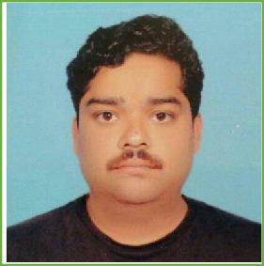FULL NAME OF CANDIDATE: - DEEPAK KUMAR

DATE OF BIRTH: - 21/12/1980 (AGE - 41 YEARS) FATHERS NAME: - LATE KAMTA PRASAD

COMPLETE ADDRESS: - 105,2ND FLOOR,OLD AG COLONY ,KADRU,

RANCHI ,JHARKHAND 834002

MOBILE NO: -9199393171

EMAIL ID: - [deepak.krdsm@gmail.com](mailto:deepak.krdsm@gmail.com)

COMPONENT I EDUCATION QUALIFICATION (MINIMUM QUALIFICATION)

|  |  |  |  |  |
| --- | --- | --- | --- | --- |
| **SL.NO** | **NAME OF**  **INSTITUATION** | **QUALIFICATION** | **DIVISION** | **REMARKS** |
| 1 | **BIHAR SCHOOL EXAMINATION BOARD PATNA** | **MATRIC** | **2ND DIV** | **1996** |
| 2 | **BIHAR INTERMEDIATE EDUCATION COUNCIL PATNA** | **INTERMEDATE** | **2ND DIV** | **1998** |

HIGHER QUALIFICATION THAN MINIMUM REQUIRMENT (IF ANY)

|  |  |  |  |  |
| --- | --- | --- | --- | --- |
| **SL.NO** | **NAME OF INSTITUATION** | **QUALIFICATION** | **DIVISION** | **REMARKS** |
| 1 | **BOARD OF EXAMINING AUTHORITY ( drug**  **control department) gov of Karnataka** | **Diploma in Pharmacy** | **Pass (2nd div) 2004** |  |

COMPONENT II – WORK EXPERIENCE

|  |  |  |  |  |  |
| --- | --- | --- | --- | --- | --- |
| **Sl.No** | **Name of Organization** | **From** | **To** | **No of Years** | **Remarks** |
| 1 | **Brindavan hospital @ research center pvt ltd** | **12/2004** | **12/2006** | **2** | **As pharmacist** |
| 2 | **TORRENT PHARMACEUTICAL LTD,IPCA LAB,CADILA PHARMA** | **1/2007** | **10/2018** | **11** | **Hold last post as AREA SALES MANAGER** |
| 3 | **ESIC DISPENSERY, DHURWA ,RANCHI (CONTRACTUAL)** | **1/12/2021** |  | **CONTINUES** | **AS PHARMACIST** |

Place: - RANCHI  Date: - Signature of Candidate