**CURRICULUM VITAE**

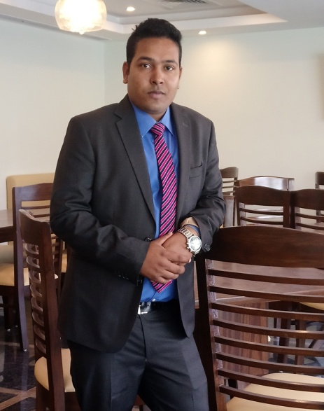

**Mr.GOUSAL AJAM**

Mobile No.:+91 7337712619,

+91 963530956

Email- [gousal618@gmail.com](mailto:gousal618@gmail.com)

**ADDRESS: PRESENT**

Kempagowda International Airport Road

Tarabanahalli,Chickjhalla P.O,Behind ITC factory,

BANGALORE, STATE-KARNATAKA, PIN- 562157

CAREER OBJECTIVE

Strive to add a value in Management and business development with my

Caliber and skills and seeking dynamic opportunities to share my

Professionalism**.**

Work in challenging and professionally satisfying environment by Utilizing my knowledge and skills to benefit the company. I’m hardworking, conscientious individual with strong sense of responsibility and willing to develop skills and techniques, which will potential advancement in hospitality industry.

.

WORK EXPERIENCE

1* Worked as industrial trainee in Starling lake View Resort in Tamil Nadu Kodaikanal

INDIA (29/05/2009 to 03/11/2009)

.. 2 month working in a food and beverage service

.. 2 month working in a Font Office

.. 1 month working in a House Keeping

.. 1 month working in a Food Production

**2* Worked as a Waiter in F&B Service Hotel Hill View International in Lonavala**

**Maharashtra INDIA (01/04/2010 to 05/04/2011)**

.. Working as a Waiter in Room Service, Special Restaurant along with Banquet.

**3* Worked as a Sr. Waiter in F&B Service Royal Orchid Resort Bangalore INDIA**

**(16/05/ 2011 to 04/10/2013)**

.. Worker in a Bar along with taking care of Multi Cuisine Coffee shop, taking inventory of

Liquor, CCG and Maintaining of all Record in Bar, With Taking care of Banquet

Function.

**4* Worked as a R.S.O.T in F&B Service Oakwood Premier Prestige Bangalore**

**(6 month**)

.. Taking Care of all Room amenities, and food order, VIP guest, along with maintaining

All pepper work, taking care of all compliant

**5* Worked as a waiter in My Grand Father House Dammam Saudi Arabia**

**(04/06/2014 to 08/10/2015)**

.. I worked As an Arabic Special Restaurant taking care of guest order or maintaining food

Order timing,

**6* Worked as a captain in Wind Flower Resorts & Spa (25/10/2015 to 12/06/2016)**

.. Taking care of all bar inventory with Weakley training class about food and some liquor,

Maintaining hygienic, check grooming part of all staff,

**7* Worked as a Team leader in Royal Orchid Re Gen Ta Inn pre-opening,**

**(13/06/2016 to 15/02/2017)**

.. Taking care of all outlets like Banquet, Restaurant, Room service,

Taking care of all booking like Conference, Buffet,

Taking care of up selling item, menu planning, Cost control, Sales Revenue,

Check all staff grooming, take training class, service standard.

**8* worked as a ARM in pre-opening Icon Group of Hotels**

**(18/02/2017 to 08/03/2019)**

.. Taking care of all outlets like Banquet, Restaurant, Room service, bar, 2 Specialty Outlets

Taking care of all booking like Conference, Buffet, Banquet Party

Taking care of up selling item, menu planning, Cost control, Sales Revenue,

Check all staff grooming, take training class, service standard.

**9*presently working as a ASST F & B MANAGER in pre-opening Royal Lotus View**

**Resotel (09.03.2019 to till date)**

Taking care of all outlets like

Two Banquet hall with party booking, day outing, conference, marriage function

Restaurant with 24 hrs coffee shop with menu planning and coffee shop menu, sales

Revenue

Room service standard

70 cover Bar,

Taking care of offer promotion like IPL, Sunday brunch

Taking care of all booking like Conference, Buffet, Banquet Party

Taking care of up selling item, menu planning, Cost control, Sales Revenue,

Check all staff grooming, take training class, service standard.

APPLY POST FOR

* FOOD & BEVERAGE MANAGER

QULIFICATION

* Passed 10th SANTOSPUR J.M VIDYAPITH from Board Of West Bengal [2006]
* Passed 10th+2 SANTOSPUR J.M VIDYAPITH from Board Of West Bengal [2009]
* I have pursue BA from Rampurhat College
* Computer Basic.
* I have done BHM in Mountain Institute of Hotel Management.

STRENGTH

* Overall extensive skill in dealing with different types of guests & handling problems in professional way.
* eager to learn & work hard, able to work any situation and very well in team

AREA PREFERENCE

* Food and Beverage Service

PERSONAL PROFILE

Name : **Mr. GOUSALAJAM**

Father’s name : Ayub Ali

Age : 27+

Marital Status : Unmarried

Sex : Male

Religion : Muslim

Nationality : Indian

Language Known : HINDI, ENGLISH, ARABIC & BENGALI

Permanent Address : Vill – Ambha,P.o-Kaluha P.S – Mar gram

Dist – Birbhum, State- West Bengal, pin-731224

Passport Details : Passport no- Z2560197

Date of issue- 14/02/2013

Date of Expire- 13/02/2023

Place of issue – BANGALORE (INDIA)

DECLARATION

I do hereby declare that the particulars filled above are true to the best of my Knowledge and belief.

**Date:**

**Place: Bangalore (GOUSAL AJAM)**