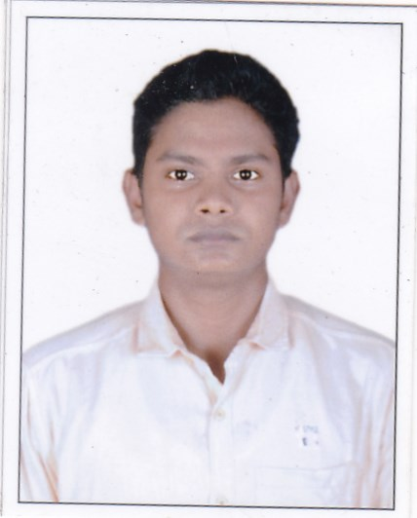
RESUME

Shib Shankar Chowdhury

VPO- Belkash , Burdwan (West Bengal), Dist. – East Burdwan
Pin Code – 713102
Email: shibshankarchowdhurybdn@gmail.com
Phone No: +91- 9593562608/6296208998

CAREER OBJECTIVE

To be a part of the team which strives for the better growth of the organization and which explores my potential and provides me with the opportunity to enhance my talent with an intention to be an asset to the company.

EDUCATIONAL QUALIFICATIONS
Degree / | Institution/ | Year | CGPA / Percentage
Certificate | Board
Diploma (MECH) Bandwan Government Polytechnic |  | 2017 | 74.6
 | College, Bandwan, Puruliya
HSC | Rathtala Manohar Das Vidhyaniketan, | 2014 | 66.67
 | Rathtala, Burdwan
SSC | Belkash Panchanan Public School | 2012 | 54
 | Belkash , Burdwan

TECHNICAL SKILLS
Software: CNC Machining and Programming

INTERNSHIP

Duration:- 13th OCTOBER TO 28th OCTOBER (2016)
Organization:- WAGAN REPAIR WORKSHOP.
Description:- Worked as a Trainee in Die-Casting.

WORK EXPERIENCE
Organization: Focus Automation
Designation : Quality Inspector
Duration : 1 Year

AWARDS AND HONOURS
First Prize- Bandwan Polytechnic Cricket Competition (2016)

Third Prize – Belkash-School Annual Run Competition (2008)

LANGUAGES KNOWN
English, Hindi, Bengali

HOBBIES
Listening to Music, Playing Cricket ,

STRENGTH: Hard Working

WEAKNESS: Straght Foroward

PERSONAL DETAILS
Mother’s Name: Mrs Bimla Chowdhury

Father’s Name: Mr Shyam Narayan Chowdhury
Date of Birth: 13 – 11 – 1996
Gender: Male

Caste : SC

I do hereby declare that the above mention information is correct to best of my knowledge.

Shib Shankar Chowdhury

PLACE: West Bengal Purba Bardhaman

