**CURRICULUM VITAE**

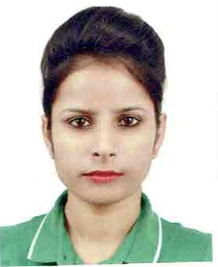

**Personal Profile**

Name : Mandeep Raj

Nationality : Indian

Address : 276, phase-4, Mohali, SAS NAGAR

(sector-59)

Age : 26

Date of Birth : 13 jan 1994

Marital Status : Single

Contact No : +917696370537

Email : rajmandeep13@gmail.com

**Working Experience**

* **Company name. : marche restaurant Singapore pvt.ltd.**

**Job title. : cashier**

**Date joined and left. : 2018-2019**

* **Company name : OPPO PVT. LTD**

**Job title : promoter**

**Date joined and left :** 2017- 2018

Main activities and responsibilities

* **Sales**
* **Promoting**
* Able to communicate with customers

**Educational Background**

* 2018 to March 2019 : **Advanced Diploma in Tourism & Hospitality**

Coleman College, Singapore

* Marketing in Tourism and Hospitality
* Development and Planning in Tourism and Hospitality
* Managing Change and Innovation
* Industrial Project/ Management Research
* 2016-2017 : Post graduation diploma in computer application
* 2013-2016 : **Bachelor of Arts**
* 2012-2013. : 12th

**Spoken/ Written Language**

* English
* Hindi
* Punjabi

**Attendance in School – Good / Fair / Poor**

**Lecturer’s Recommendation: -**

____________________________________________________________________________________________________________________________________________________________________________________________________________________________________________________________________________________________________________________________________________________________________________________________________________________________________________________________________________________