RESUME

Name: Vishal Yadav  Address : Vill-Tikari, Post-Babhani Hethar  Distt: Prayagraj (U.P.)-212303  Mob. No: +919415022164    Email ID : vishalyadav094150@gmail.com  https://www.linkedin.com/in/vishal-yadav-a56b83177 | 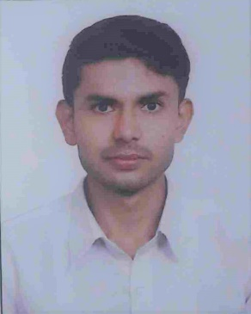

CAREER OBJECTIVE :

To use my abilities in my area and along with complete the objective and goals of the organization. I want to take this skill for forward with this organization for further future.
PROFESSIONAL QUALIFICATION :

Management Diploma in Materials Management.
Name | Semester | Year | Percentage
Institute of Engineering & Rural Technology Allahabad | First | 2017-18 | 75.06%
 | Second | 2017-18 | 74.83%
 | Third | 2018-19 | 79.00%
 | Fourth | 2018-19 | Appearing
ACADEMIC QUALIFICATIONS :

Sr. No. | Exam Passed | Board | Year | Percentage
1. | Intermediate | U.P. Board | 2015 | 77.02%
2. | High School | U.P. Board | 2013 | 75.33%
3. | Graduation ( B.A) | CSJM Kanpur University | 2018 | 53.88%

COMPUTER SKILL :
- MS: Office.
- Power Point.
- CCC.
PROJECT WORK :
- Project work on purchase procedure in BPCL.
- Project work on store procedure in BPCL.
- Project work on Case Study of Storing System of Twenty Items.
- Project work on a case study of International Buying.
TRAINING
- Store & Purchase Dept. in B.P.C.L. Naini Prayagraj (Allahabad).
ACHIEVEMENT :

- National Service Scheme.
- Central Vigilance Commission. (C.V.C)
- Certificate in Active participation in National Mission for Clean Ganga.

STRENGTH :
- Hard working.
- Writing (Motivational Speech, Poem & Songs And Shayaries)
- Punctuality.
- Communication Skill.
PERSONAL DETAILS :
Father's Name : Mr. Umashankar Yadav
Mother’s Name : Mrs. Shyama Devi
Date of Birth : 01-07-1998
Gender : Male
Language Known : Hindi & English
Marital Status : Unmarried
Religion : Hindu
Nationality : Indian

DECLARATION :

I hereby declare that all the above information given is true to the best of my knowledge and belief and I shall join the company in case of my Selection.

Date:
Place: |  | Signature

