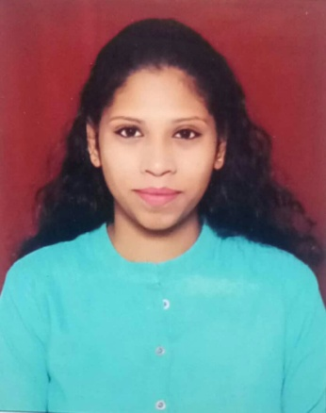­­­­­­­­­­­­­_____________________________________________________________________________________________________

P. Valentina Dior

H.No1-18-116 Police Lines,

Rasoolpura, Secunderabad,

Hyderabad, Telangana-500003.

9398892692

[valentinadior1997@gmail.com](mailto:valentinadior1997@gmail.com)

­­­­__________________________________________________________________________________

Career Objective :

To obtain a creative and challenging position in an organization that gives me an opportunity for self improvement and leadership, while contributing to the symbolic growth of the organization.

Academic Qualification :

* Completed B.COM Computers Finance from St. Francis Collage with an aggregate of 57%.
* Completed C.E.C from Maharishi Veda Vigyan Mahavidyalaya Collage with an aggregate of 65%.
* Completed SSC from St. St. Mary’s High School with an aggregate of 60%.

Additional Qualification :

* Project Management

Strength :

* Adaptable to any situations
* Friendly nature
* Organisational skills

Extra-Circular Activities :

* Dancing
* Stage dramas
* Being an active coordinator at events

Interests :

* Art And Craft
* Singing
* Dancing
* Yoga

# PERSONAL PROFILE:

Name : P. Valentina Dior

Fathers name : P. Shirish Kumar

Mothers name : P.Irene

Date Of birth : 19 / 06 / 1997

Address : H.No1-18-116 Police Lines, Rasoolpura, Secunderabad,

Hyderabad, Andhra Pradesh-500003

Tel no. : 9398892692

Email Id : [valentinadior1997@gmail.com](mailto:valentinadior1997@gmail.com)

Nationality : Indian

Religion : Christian

Languages known : English, Hindi and Telugu

Aadhaar no. : 2613 8366 7594

Passport no. : M7923134