RESUME
BICKY KUMAR
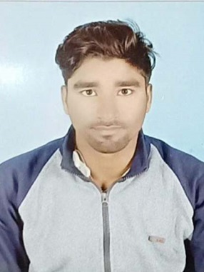
ARGADDA GM OFFICE (RAMGARH), PO- SIRKA, PS- RAMGARH
DIST- RAMGARH, PIN- 829101(JHARKHAND)
CONTACT NO. – 7488807662

PERSONAL PROFILE
NAME : BICKY KUMAR
FATHER’S NAME : RATI RAM
DATE OF BIRTH : 16-SEPTEMBER-1998
GENDER : MALE
MARITAL STATUS : UNMARRIED
NATIONALITY : INDIAN
RELIGION : HINDU
LANGUAGE KNOWN : HINDI & ENGLISH

EDUCATION QUALIFICATION:-
EXAM | INSTITUTION/UNIVERSITY/BOARD | YEAR OF PASSING | DIVISION(%)
MATRICULATION | JAC RANCHI | 2015 | 54%
INTERMEDIATE ARTS | JAC RANCHI | 2017 | 52%

WORKING EXPERIENCE:-
- Sales manager
- Root Deblopar
- Sales Executive

DECLARATION
I HERE BY DECLARE THAT ALL THE ABOVE INFRMATION IS TRUE TO BEST OF MY KNOWLEDGE AND BELIEF.

DATE :……………….
PLACE :…………… SIGNATURE
……………………………………………..

