MANOJ KISAN MENDHE
COMPUTER SCIENCE ENGINEER

PROFESSIONAL SUMMARY
- Operational Executive (Network Engineer) with more than 4.5 years of increasing responsibilities in technical leadership, computer technology, and business-critical management.
- Expertise in networking concepts, TCP/IP protocol, and network security, knowledge of Network setup and administration, management, and quality of service.
- Proven diagnostic abilities with attention to detail and ability to work effectively in a fast-paced environment.

EDUCATIONAL
Address: OMKAR NAGAR, NEAR BHAVANI SQUARE, MAHSOOL COLONY, CHANDRAPUR - 442401
Contact Number: 8983526619
Email Address: manojmendhe42@gmail.com

CAREER OBJECTIVE
To become a reliable network engineer who will be able to assist the company or organization towards achieving its mission & goals.

EMPLOYMENT EXPERIENCE

CORE INTEGRA CONSULTING SERVICES Pvt.Ltd.
(Project Based On TCSiON)
OPERATIONA EXECUTIVE (Networking Engineer) JAN - 2015 - Present
  - Providing daily operational support and system administration for core network infrastructure.
  - Assisting with project scope development. Involved in developing Networking standards, procedures and documentation. Monitoring network performance.

TECHNICAL SKILLS

BACKGROUND

BATCHLER OF ENGINEER IN COMPUTER SCIENCE & ENGINEERING
Gondwana University of
Gadchiroli Maharashtra India Final Year Appearing
- Troubleshooting
- High technical
- Active learning
- Organizational skills

COMPUTER SKILLS
- Problem solving
- Innovative thinking
- Critical Thinking

Diploma in Computer
- Hardware & Networking • Microsoft OS

M.S.B.T.E. University 2010 - 2013
Mumbai, Maharashtra,

HIGH SCHOOL
- Core JAVA (Beginner)
- C AND C++ Language & Data Structure

PERSONAL SKILLS
- LINUX OS
- MS – OFFICE Document Imaging Scanning (Advance)

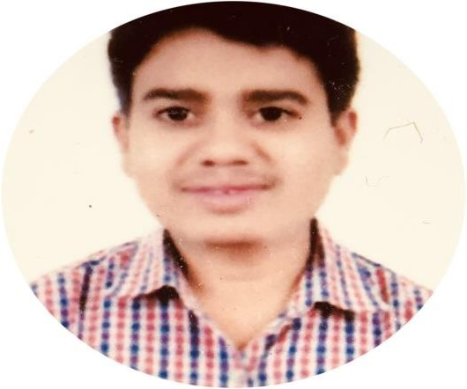
2006 - 2008
Arts, Commerce & Science
Tukum Rd,Chandrapur, Maharashtra

SECONDARY SCHOOL
2006 - 2008
Bhavanji Bhai Chavhan High School MUL Rd, Chandrapur,
- Good at ﬁnding fast and effective solutions to various Problems.
- Very organized and disciplined.
- Respectful, well-mannered, and punctual.
- Willing to learn and is ﬂexible in any source of Technical matters.

