CURRICULUM VITAE

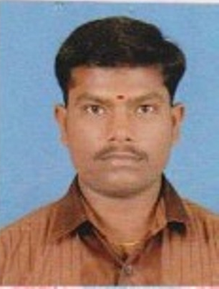

K.MANIKANDAN DCSE, B.E.,

Contact Number

Mobile No: 8344360254

Email

Kmanicse01@gmail.com

Permanent Address

11/34, kumarapatti east,
Viralimalai Road,
Manapparai - 621306

Personal Details

Date of Birth : 30.01.1987

Father’s Name : R.Kandaiah

Sex : Male

Marital Status : Married

Nationality : Indian

Religion : Hindu

Languages known: English, Tamil (Read, Write and Speak)
Career Objective

To seek a responsible and challenging position that will use my education and experience, in expanding my knowledge, and my experiences will help the students to face this competitive world.
Work Profile

- Mother Terasa Polytechnic College – Iluppur
- 16.07.2008 – 06.06.2009 – Instructor & Lecturer Senior Lecturer
- Annai Terasa Polytechnic College – Pudukkottai
- 07.06.2009 – LECTURER, COMPUTER OPERATOR 08-06-2011- 30.05.2015
- PG Teacher in computer science in Vinmathee Matric Hr Sec.School Manaparai 01.06.2015 – till Date.

( Oct 2008 & April 2009)

Work Exposure: -
- Data Entry operator
- Administrative work,
- Heading the Discipline Committee, Enquiry Committee and Parents Counseling.
- Acting as Exam Cell for Local Exams and Board Exam.
- Organized Industrial Visits,
- Helped Co-staff members with issues relating to classroom management, teaching methods.
- Coordinated and Participated Convocation Functions, Annual Day Celebrations, NSS Camps.
- Organized resources for specially planned events.

Education Qualification

- B.E ( Computer Science and Engineering) Kurinji College of Engineering And Tech – Manaparai
- Diploma in Computer Engineering
Year: (2008 from Board of Technical Education – Chennai in Government
Polytechnic College - Trichy
- Higher Secondary Education [12th]
Year: (2005) from T.Alai Higher Secondary School - Manaparai.
- Secondary Education [10th]
Year: (2003) from st.Joseph Higher Secondary School - Manaparai

Computer Literacy

Packages : MS Office 2007 package,
Operating System : Windows XP, Windows 2000 .NET ORACLE VB .BASIC
Languages : C & C++, HTML, RDBMS.
Technical tool : Hardware installation, Service
Typing : English & Tamil (Both Higher)
Declaration

I, K.Manikandan, hereby do confirm that the information given above is true to the best of my knowledge.
SIGNATURE
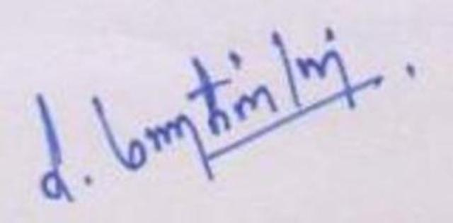
( Manikandan K)

