## CURRICULUM VITAE

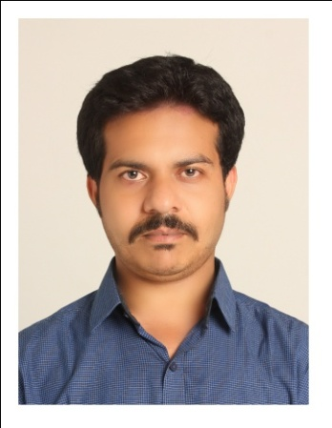

**Present Address:**

**Mr. KANHU CHARAN PADHY**

**Deputy ManagerManager MIS & IT**

O/o: **Adhikar Microfinance Private ltd**

**Plot No 77/180/970, Subudhipur, Tamando**

**Bhubaneswar, Pin-752054**

Email:-[kanhucharan.mis@adhikarindia.org](mailto:kanhucharan.mis@adhikarindia.org)

**Permanent Address:**

**Mr. KANHU CHARAN PADHY**

S/o: NeelaKanthaPadhy

At-Panaspadi / Po-Balliguda

Dist.-Kandhamal,

Odisha, Pin-762103

Mob. No.:9439268213,8249592240

Email: - [kcpadhy.blg@gmail.com](mailto:kcpadhy.blg@gmail.com)

**CAREER OBJECTIVE:**

Looking forward for a responsible and challenging position with a growth oriented company where my talent and knowledge will significantly contribute to the company’s future growth and profitability.

**Current Working at Adhikar Microfinance Private ltd.**

Now I am working as Deputi Manager MIS & IT for “**Adhikar Microfinance Private ltd”** from 2nd Jan 2019

**AREAS OF EXPOSURE and EXPERTISE IN “MAHASHAKTI FOUNDATION, Head Office, BALANGIR”. (11 Years 3 Months)**

Lastly I was working for Mahashakti foundation (http://www.mahashaktifoundation.in) as Manager IT.

* I associated with this institution on 15.02.2007 with Micro Finance System.
* I promoted to Regional Accountant on sept.2009, in this time I prepared accounts in *Tally 7.2*for 15 branches and also looks after on MIS.
* I managed HO level MIS since 05.06.2011 to 31.05.2018 as **Manager IT**.
* Accomplishes information technology staff results by communicating job expectations; planning, monitoring, and appraising job results; coaching, counseling, and disciplining employees; initiating, coordinating, and enforcing systems, policies, and procedures.
* Maintains staff by recruiting, selecting, orienting and training employees; maintaining a safe and secure work environment; developing personal growth opportunities.
* Maintains organization's effectiveness and efficiency by defining, delivering, and supporting strategic plans for implementing information technologies.
* Directs technological research by studying organization goals, strategies, practices and MIS.
* Completes works by coordinating resources and timetables with user departments and MIS department.
* Preserves assets by implementing disaster recovery and back-up procedures and information security and control structures.
* Recommends information technology strategies, policies, and procedures by evaluating organization outcomes; identifying problems; evaluating trends; anticipating requirements.
* Maintains quality service by establishing and enforcing organization standards.
* Maintains professional and technical knowledge by attending educational workshops; reviewing professional publications; establishing personal networks; benchmarking state-of-the-art practices; participating in professional societies.
* Contributes to team effort by accomplishing related results as needed.
* Maintaining HO MIS and compiling with database.
* Reporting to Authorities as needed.
* Also I was looking the BC Operationsand System developing for business correspondence of IDBI and YesBank. More than 200 Crore loan disbursed under my supervision.

**AREAS OF EXPOSURE and EXPERTISE IN “MAHASHAKTI FOUNDATION, Head Office, BALANGIR”. (11 Years 3 Months)**

I worked as Manager MIS for “**Agri Link Food Processing Pvt Ltd”** from 1st September 2018 to 1st Jan 2019

**ACADEMIC QUALIFICATION:**

* Matriculation with 1st class from Board of Secondary Education, Orissa in 2000.
* Intermediate in Science from Council of Higher Secondary Education, Orissa, Bhubaneswarin 2002.
* Graduate in Commerce from EIILM UNVERSITY with 1st Class.

**COMPUTER PROFICIENCE:**

* PG Diplomain Computer Application from Odisha Computer Sakharta Mission

(Window O.S., MS Office, Internet, HTML/XML, C+, C++, Email and internet).

* Proficient with the use of accounting and financial related software.

**SOFT SKILL:**

* Good attitude.
* Honesty.
* Desire to learn and be trained.
* Positive work ethic.

**PERSONAL DETAILS:**

Mothers Name : Mrs. KushumManjulaPadhy

Fathers Name **:** Sri NeelakanthaPadhy.

Date of Birth **:**  2nd April 1985

Marital Status **:**  Unmarried

Nationality **:**  Indian

Sex **:**  Male

Language : English, Oriya and Hindi

Hobbies : Reading Stories and singing

*I do here by declare that all the information furnished above are true and correct to the best of my knowledge.*

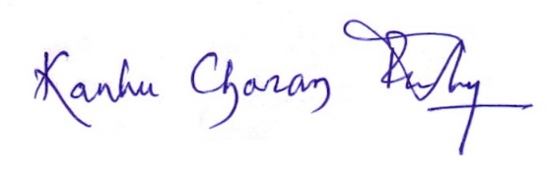

**Date:08.06.2019**

**Place:** Bhubaneswar **(SIGNATURE OFAPPLICANT)**