**CURRICULUM VITAE**

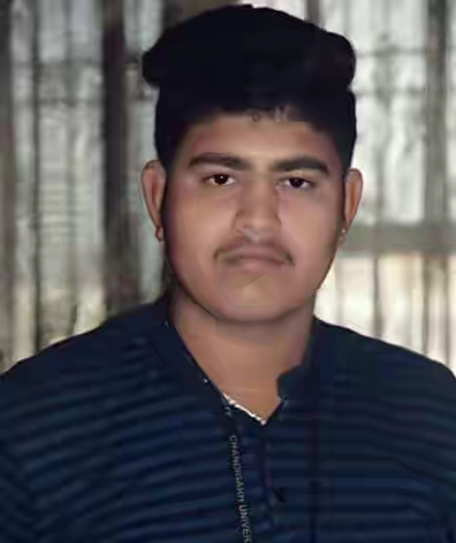

**MUNISH KUMAR**

**OBJECTIVE**

**To work in challenging environment where new and innovative ideas are accepted encouraged and worked upon and to be an asset of the company**

**ACADEMIC QUALIFICATION**

|  |  |  |  |  |
| --- | --- | --- | --- | --- |
| **Year** | **Course** | **Name of Board/University** | **Percentage** | **Division** |
| 2018 | MBA | Chandigarh University | 57% | 2nd |
| 2016 | BA | Himachal Pradesh University Shimla | 6.8CGPA | 1st |
| 2012 | XIITH | HP Board | 60% | 1st |
| 2010 | XTH | HP Board | 55% | 2nd |

**MANAGEMENT TRAINING AND PROJECT DETAILS**

|  |  |
| --- | --- |
| **Company Name** | V Solution Group |
| **Project Title** | E Business Marketing |
| **Training Period** | 01ST June – 15TH July’2017 ( 45 Days ) |

**COMPUTER SKILLS**

* Basic of MS Office.
* Knowledge about Internet and World wide web.
* Working knowledge of windows 7 .
* Software Packages such as SPSS.

**CORE MANAGEMENT COMPETENCIES**

* Analytical and Problem-solving abilities.
* Good Communication and Listening skills.
* Behavioural skills such as Confident, Initiator and provides motivation.
* Leadership qualities.

**ACHIEVEMENTS**

* Play intercollege cricket tournament
* Selected as a CR of BA

**EXPERIENCE**

* 1 Year Experience in Bajaj Finance Limited. On the Designation of Assistant Branch Sales Manager.

**PERSONAL DETAILS**

**DOB:** 15 November 1994

**Age:** 25 Years

**Father Name:** Madan Lal

**HOBBIES**

* I love to play sports like cricket
* In my free time, I really like to do wild photography. I find that whenever I do photogrhapy, I feel that world around us is more beautiful

**DECLARATION**

I hereby, declare that the information furnished above is true to the best of my knowledge.

**Name:** Munish Kumar

**Contact No:** +91- 8988017515

**Address:** Village- Pansai Post Office- Pansai Tehsil –Nadaun Distt -Hamirpur

**Email:** munishkumar16mba1050@gmail.com

**Date:**

**Place:**