UMESH VASHISTH
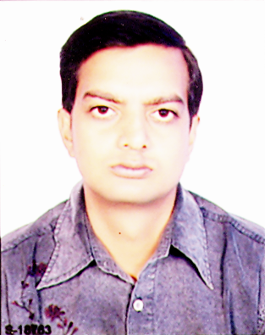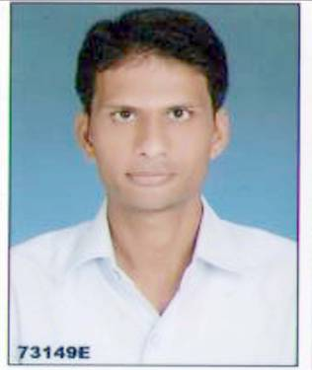

3-E-11,Dada Bari
Extension, Kota
Pin: 324009
Rajasthan E-mail : umesh_vas21585@yahoo.com
Mobile : +919509266629
Career Objective:

Contribute my management skills and strong commitment to become a specialist in my profession. Willingness to take risks in an organization.
Professional Qualification:

- MBA from Cerebral Institute of Management & Technology, Kota affiliated by NIMS University, Jaipur
Specialization: Finance
- Post Graduation Program in Management from Institute of Management & Technology, Kota
Specialization: human reached (H.R)
Academic Qualification:

- BSC form kota University, kota
- Senior Secondary From RBSE, Ajmer (PCB)
- Secondary from RBSE, Ajmer
Offical Projects Work :

- Gowerdhan pura flyover canal bridge kota
- Bundi main road bridge kota
- Station army get bridge kota
- Channel (kerla) bridge kota
- 99 bridge (shrilanka) kota
Personal Work Experience :

Organization : Dynamic engineer’s pvt. Ltd., PAYTM Pvt. Ltd (Previous)
Duration : 5 year appearing , 4 year
Type of Job : Production Manger (T&T), Marketing And Lyazing mangement (T&T)
Place : Rajasthan

Area of Interest:

- Software Engineering
- Customer Relationship Management.
- Financial Services
- Marketing - sales
Projects:

- RELIANCE MOBILE (during MBA first year)
- INGA VAYSA (Summer Project in MBA Final Year)
- Market research on Colgate (MBA first Year)
- A Study on Mobile Banking in India (Final Project in MBA) .
Achievements-co-curricular & Extra Curricular:

- Head Boy of the Campus in CIMT, Kota
- Certified DTP Operator
- Attended Management Meets in NIMS University.
- Seminars and training programs attended.
Personal Skills:

- Ability to build customer relationships.
- Strong written and verbal communications.
- Fast learner and Hard Worker.
- Willing to work efficiently and effectively.
Personal Profile:

Father’s name : Mr. AMI CHAND VASHITH
Date of Birth : 21-May-1985
Gender : Male
Marital Status : Marrige
Nationality : Indian
Hobbies : high jump , race bike & car.s
Declaration:

I hereby declare that the information given is true and correct to the best of my knowledge.

Place : kota (Rajasthan)
Date : / (UMESH VASHISTH)

REFRANCE :HR

