**MANSI** 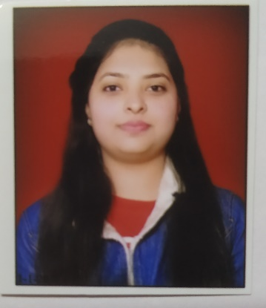

Mob-9716816744

[Email-myselfmansi18@gmail.com](mailto:Email-myselfmansi18@gmail.com)

Add.-k-1189,90 Jahangir Puri,

Delhi-110033.

**OBJECTIVE**

To work with maximum potential in a challenging and dynamic environment, where freedom of working for initiatives is ensured and achieve self-development by playing a significant role in building the organization.

**ACADEMIC DETAILS**

|  |  |  |  |  |
| --- | --- | --- | --- | --- |
| **DEGREE** | **COLLEGE** | **BOARD/UNIVERSITY** | **YEAR OF PASSING** | **PERCENTAGE** |
| B.tech(cse) | Maharaja Surajmal Institute of Technology, New Delhi. | GGSIPU | Pursuing | ---- |
| Senior Secondary School | Kendriya vidyalaya | CBSE | 2017 | 73.6% |
| Higher Secondary School | Kendriya vidyalaya | UNIVERSITY | 2015 | 72.2% |

**Project details**

|  |  |
| --- | --- |
| **Project Title** | AIRLINE RESERVATION SYSTEM. |
| **Duration** | JUNE 2019 – JULY 2019 |
| **Technology Used** | Core Java, Java Swings, JDBC . |
| **Database** | MySql |
| **Software used** | NetBeans |
| **Project Details** | *AIRLINE RESERVATION SYSTEM*is a web application used to store and retrieve information. user can see the flights where he/she want to go. based on that, they book their flights and their information will automatically stored in database which can be retrieve by the admin account. |

**Technical Skills**

* Languages -C,C++, JAVA,SQL,HTML,CSS
* Concepts-OOPs
* Database-MYSQL
* Area of Interest-JAVA
* Tools-turbo C, code::blocks, dev C++, Netbeans.
* OS-Windows

**PERSONAL DETAILS**

FATHER’S NAME : MR. RAM KISHOR

DATE OF BIRTH : 18/03/2000

LANGUAGES KNOWN : Hindi, English.

NATIONALITY : Indian