**PRASHANT D SAWANT / RESUME**

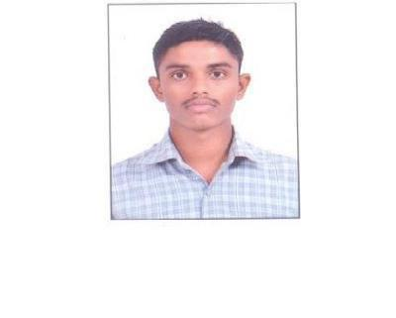

**Permanent Address**

294-savita nagar society,Bakrol road

Phone : 9016977478

B/h-vaibhav cinema,Bakrol

Email : prashantsawant921@gmail.com

Anand,Gujarat-388315

College

:VP & RPTP SCIENCE COLLEGE

**Career Objective**

To achieve excellence in my life, And do work practically to solve real world problems.

**Technical Skill**

➢ 

➢ 

**Web Programming Web Designing**

: HTML,Javascript

: ASP.NET C#

**Strengths**

➢Hardworking

➢Self-Learner

➢Good Team Player

➢Leadership

**Academic Profile**

|  |  |  |  |  |
| --- | --- | --- | --- | --- |
| **Degree** | **Board/University** | **Enrollment No.** | **Year** | **Score** |
|  |  |  |  |  |
| M.sc [IT] | S.P University | ID- 1309748 | MARCH 2018 | 6.9 |
|  |  |  |  |  |
| B.sc [cs] | S.P University | 1309748 | MARCH 2016 | 5.69 |
|  |  |  |  |  |
| H. S. C. | G. S. E. B. | B177409 | MARCH 2013 | 53.8% |
| S. S. C. | G. S. E. B. | B367527 | MARCH 2011 | 56.2% |
|  |  |  |  |  |

**Job Experience**

* Working as a Tr Sec Exe in SPICEJET LTD from DEC’2018 till date.

**Achievements**

* Anand Dist Rifle Shooting Competition
* Gujarat state Rifle Association
* Selected for SSB NCC camp kamptai
* Selected for IMA attachment Dehradun
* Dist level football competition
* NCC `C’ certificate with `B’ grade
* Secured first position in brainwaves competition

**Workshops and Seminars conducted**

 ➢I have attend campus carnival 2015

 ➢I have attend mobile app workshop seminar 2017

 ➢I have attend one day seminar shivam campus 2017

**Personal Details**

Date of Birth

: 24th oct 1993.

Languages Known

: English, Hindi, Gujarati & Maharati.

Marital Status

: Single.

Hobby

: Playing football, Watching news.

Willingness to Relocate

: Yes.

Acitivity

1. Play football
2. NCC
3. Air rifle shooting

I hereby declare that the information furnished above is true to the best of my knowledge.

Place: Anand

Date:

Prashant Sawant