**Prashant Upadhyay**

Contact No.: -**9794522525**

E-mail:- prashantupadhyay95on@gmail.com

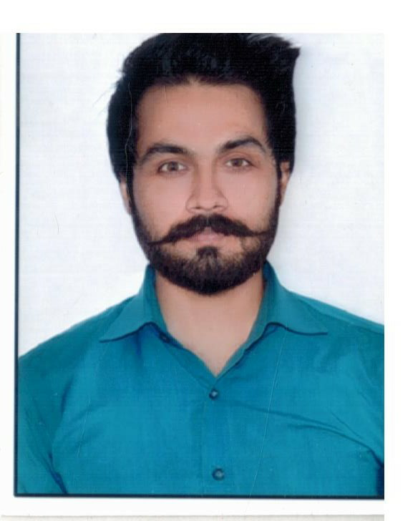

**Vill- Baserawan, Post-kaserawan Dist- Jaunpur (U.P.) Pincode  222165**

**CAREER OBJECTIVE**

To work in a firm with a professional work driven environment where I can utilize and apply my knowledge, skills which would enable me as a fresh graduate to grow while fulfilling organizational goals.

B**ASIC ACADEMIC CREDENTIALS**

|  |  |  |  |
| --- | --- | --- | --- |
| **Qualification** | **Board/University** | **Year** | **Percentage** |
| B.A. | CSJM Kanpur.University | 2013-2015 | 56% |
| Intermediate | N.I.C. Janghai Jaunpur(UP) | 2012 | 60% |
| High School | V.S.HSS.P.KHUSH HAL S.R.N Bhadohi | 2010 | 51% |

**IT PROFICIENCY**

* Microsoft Office Word, Microsoft Office Excel, Microsoft Office Power Point
* Internet Browsing
* **Language:** *C*
* **General and graphic application:** *JAVA Script*

**ACHIEVEMENTS**

* Won a gold medal in atheletics in college championship.
* Member of 1st runner up volleyball team at district level.

**INTERPERSONAL SKILL**

* + Ability to rapidly build relationship and set up trust.
  + Confident and Determined
  + Ability to cope up with different situations.

**PROFESSIONAL SKILLS**

* Worked with HDFC ERGO GIC LTD. As a Process associate from December 2016 to 1st May 2019 , in the Motor and Health Insurance
* Worked with Maxbupa health Insurance ltd at the post of Telesales executive from 15th May 2019 to 15 June 2020.

**PERSONAL DETAILS**

* **Fathers Name :- Shri Bhola Nath Upadhyay**
* **Permanent Address :- vill-Baserawan post kasawaran dist-jaunpur (up)**
* **Date of Birth :- 15thJuly 1995**
* **Language Known :-** English & Hindi
* **Marital Status :-** Single
* **Nationality/Religion :-** Indian / hindu
* **Interest & Hobbies :-** Internet browsing ,playing cricket, volleyball and watching movies

**DECLARATION**

I do hereby declare that the above information is true to the best of my knowledge**.**

**Place: Prashant Upadhyay**

**Date: (Signature)**