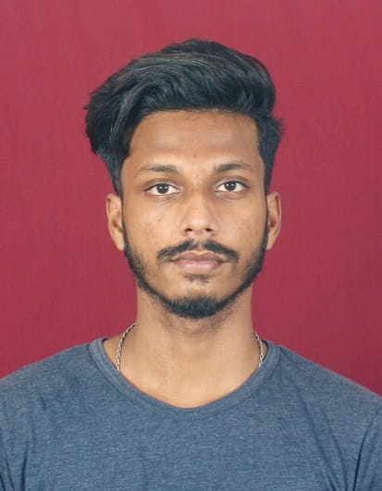 **CURRICULUM VITAE**

**TAHMID KHAN**

C/O- SAYEED KHAN

At- Dewan Bazar,

Po-Buxi bazar, p/s-Lalbag

Dist- Cuttack -753001

Mobile-7978508451

Email I.D – tahmid07860@gmail.com

|  |
| --- |
|  |

**OBJECTIVES** :To work in an organization where I shall be able to utilize

and enhance my skills and potential abilities to meet

challenges of growing demand at every situation. I am

a learner compatible person and hope to complete the

given assignment on time .

**EDUCATIONAL QUALIFICATION**:

|  |  |  |  |
| --- | --- | --- | --- |
| **Name of the Exam** | **Name of Institution / Board / University** | **Year of passing** | **% of marks** |
| **10th** | **Board of Secondary Education , Odisha** | **2014** | **56%** |

**EXTRA QUALIFICATION**:

|  |  |  |  |
| --- | --- | --- | --- |
| **PGDCA** | **Ms Office, Ms Word, Ms Excel, Ms Power point, & Internet Explorer Etc.** | **2016** | **88%** |

**Experience:**

**3 years experience in SAJ FOOD PRODUCTS PVT. LTD (BISK FARM BISCUITS) as**

**a Computer Operator.**

**PERSONAL SKILLS : \***Willing to learn and update myself from time to time.

* Skills to feasible team work .

* To think positively .

* Sincere and hardworking .

* Honesty & passion for learning .

* I have the biggest confidence level and will power .

**PERSONAL DETAILS**

**1 . NAME** : TAHMID KHAN

**2 . DATE OF BIRTH** : 25/04/1999

**3. FATHER’ S NAME** : SAYEED KHAN

**4. PERMANENT ADDRESS**  : At- Dewan bazar,

Po- Buxi bazar , P.S – Lalbag

DIST: Cuttack -753001

**5. NATIONAITY** : INDIAN

**6. RELIGION**  : ISLAM

**7. CONTACT NO** : 7978508451

**8. SEX**  : MALE

**9. LANGUAGES KNOWN** : ENGLISH , HINDI & ODIA

**10. HOBBIES** : READING NEWS PAPERS ,STORY BOOKS

**DECLARATION**

I do hereby declare that all the above information in this form are true to the best of my knowledge and belief.

TAHMID KHAN

(signature of the candidate)