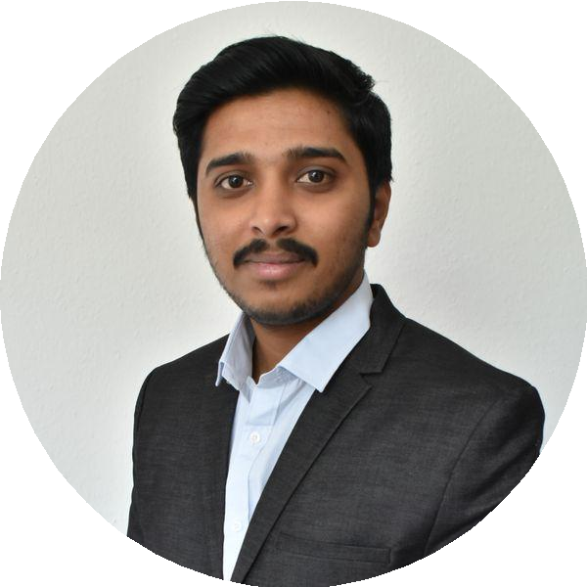AKANKSH GURUPADAPPA AKKI

**+919844507527 ** [**akki.akanksh@gmail.com**](mailto:akki.akanksh@gmail.com)

 **linkedin.com/in/akanksh-akki-99185939 ** **3370/22A, MCC B Block, Davangere 577004**

# EXPERIENCE

## Master Thesis

### INKA-Application Driven Research

 10/2019 - 04/2020  Magdeburg

**Interventional needle dynamics evaluated by audio signals - data generation and extraction of audio features**

# EDUCATION

## Master in Medical System Engineering

### Otto-von-Guericke Universität Magdeburg

 04/2016 - 2020

Development of a 3D printed experimental set-up for the test object

holder

Detection of audio signals and pre-processing Extraction of audio features

Feature analysis

Tools: Matlab, Python, SolidWorks (3D CAD), 3D slicer

## Student Project

**INKA-Application Driven Research**

## Bachelor of Engineering in Instrumentation Technology

### Siddaganga Institute of Technology (SIT), Karnataka, India

 08/2010 - 04/2015

 10/2018 - 10/2019  Magdeburg

##### Segmentation of bone from ultrasound images using deep learning

Dataset of 600 images - divided into train and test set Line profiles drawn in Matlab to find bone area

Masks generated for train set using Matlab

U-Net convolution neural network is used for bone segmentation Tools: Matlab, Python, Keras, scikit-image, OpenCV

## Student Project

**Otto-von-Guericke Universität Magdeburg**

# SKILLS

#### Matlab OpenCV Python SQL SolidWorks (3D CAD) 3D slicer Additive Manufacturing ISO 13485

 04/2018 - 07/2018

 Magdeburg

#### MDR 2017/745 Windows Linux

##### Image processing using Python

Dataset : Caltech101

Data preprocessing using Matlab for resizing and converting to gray scale image format for all the classes

Histogram of oriented gradients (HOG) technique for feature extraction

#### machine learning deep learning computer vision Shell Scripting Microsoft office Image Processing

Supervised machine learning using support vector machine (SVM)

classification algorithm

Tools: Python, Matlab, scikit-learn, OpenCV

Student Project - Development of MEMS

**Otto-von-Guericke Universität Magdeburg**

# LANGUAGES

### English



 04/2017 - 08/2017 

Achievements/Tasks

Magdeburg

Proficient

Development of Thermal Actuator using silicon and aluminium Development of Thermal Actuator in clean room with different MEMS

### German

Intermediate



fabrication processes such as oxidation, diffusion, ion implantation,

LPCVD and sputtering

### Kannada

Native



# PUBLICATIONS

## Nanotechnology in Medical Field

### Abstract selection in BME-IDEA Europe Conference

ISBN: 978-3-944722-59-7

DOI: 10.24352/UB.OVGU-2017- 76

# ACHIEVEMENTS

 **Certificate of Appreciation and Excellence from INKA** Volunteer for IEEE EMBS International Student Conference held in Magdeburg, Germany from 22nd - 24th November 2019

### Certificate of Participation

Gained knowledge on deep learning at Summer School for

Exponential Technology based Innovation Generation held from 15-21 July 2019 by IEEE EMBS Magdeburg and INKA

### Paper Presentation of Technisuim (2015)

Secured 2nd place in Paper Presentation of Technisuim-15

### INDIAN HIP HOP DANCE CHAMPIONSHIP (2014)

Secured 2nd place in “INDIAN HIP HOP DANCE CHAMPIONSHIP

2014” held in NIT Surathkal and qualified for National Level Competition

### Idea to Execution for Entrepreneurs

Coordinated in zonal city Workshop on “Idea to execution for Entrepreneurs” which is an initiative by international business summit of IIM Ahmedabad

# CERTIFICATION

**Certificate of Completion in Udemy** Medical Device Regulation 2017(745) explained in simple terms

**Certificate of Completion in Udemy** European Medical Device Regulation explained in Simple terms

### Professional Development Through Online Course (Udemy)

[ISO 13485:2016 - Awareness on Medical Devices Development](https://www.udemy.com/course/iso-134852016-awareness-on-medical-devices-development/)