CURRICULUM VITAE
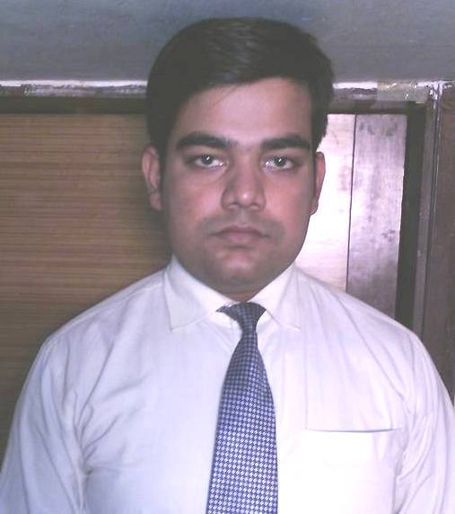Career Objectives:
Pushpraj Mishra | Mobile No.:-+91 9051052037
Garia Natun Diara  P.O-Nayabad P.S-Sonarpur  Kolkata-700150 | Email Id: pushprajji@gmail.com

To work in a growing organization where I can put my creative talent, marketing experience and management skills to test, in harmony with the organizational culture, so as to contribute significantly to the organization’s goals and in the process fine-tuning my skills and abilities.
Competencies:

- Can take initiative steps in any work.
- Ability to grasp things quickly
- Ability to motivate others
- Academic Details:
Graduation : BBA under West Bengal university of technology
Year of passing : 2012
Percentage : 68.90%
- 10+2 (Intermediate) : Techno Model School
Year of passing : 2009
Percentage : 59%
- 10th : Vidya Vikash High School
Year Of Passing : 2007
Percentage : 47.5%
Additional Qualifications : TALLY
present work experience
- Organisation : WEDDINGZ.IN (OYO)
Designation : VENUE MANAGER
Duration : JUNE 2019 –TILL DATE
Roles and Responsibilities
- To be responsible for banquet sales.
- Supervises all sales work.
- Monitors the customer data and bill.
- Deals with the customer billing and budget of Banquet.
- Helps them to choose the Venue,catering and decoration.
- Organisation : AAR GEE CRATION PVT LTD
Designation : ASSISTANT MANAGER
Duration : JUNE 2018 –MAY2019
Roles and Responsibilities
- To be responsible for staffs attendance and workers payroll
- Supervises all operational work
- Monitors the customer data and bill
- Deals with the customer outstanding
- Organisation : SPRINGFIELD PROJECTS PVT LTD [THE SPRING CLUB]
Designation :FRONT OFFICE ASSISTANT
Duration : MARCH 2015 –MAY 2018
Roles and Responsibilities
- To be responsible for welcoming guests and handling any complaints.
- Supervises reservations.
- Monitors the customer accounts.
- To ensure that all hotel standards and procedures are applied.
- To manage daily billing and payment. Dealing with members outstanding and monthly subscription.
- Organisation : HOTEL SHELDON
Designation :FRONT OFFICE & MARKETING EXECUTIVE
Duration : DEC 2014- MARCH 2015
Roles and Responsibilities
    - To be responsible for welcoming guests and handling any complaints. In doing so, he or she.
    - Supervises reservations and the allocation of bedrooms with the Executive Housekeeper.
    - Applies and ensures the application of the sales strategy to maximize occupancy and average room price
    - To monitor the quality of welcome extended to guests
    - To ensure that all hotel standards and procedures are applied
    - To manage daily billing and payment.
    - Making relationship with the new and old corporate companies, hospitals, etc

3.Organisation : HOTEL SUDESH TOWER
Designation :FRONT OFFICE EXECUTIVE
Duration : APRIL 1 – NOVEMBER 2014
Roles and Responsibilities
- To be responsible for welcoming guests and handling any complaints. In doing so, he or she.
- Supervises reservations and the allocation of bedrooms with the Executive Housekeeper.
- Monitors the customer accounts and till accounts.
- Applies and ensures the application of the sales strategy to maximize occupancy and average roomprice. To monitor the quality of welcome extended to guests.
- To ensure that all hotel standards and procedures are applied.
- To manage daily billing and payment.

4. Organisation : HDFC BANK LTD
Designation :SENIOR SALES EXECUTIVE (CO-EX)
Duration : MAY 2013-NOV2013
Roles and Responsibilities :
- Sale of banking products like current, savings, recurring, fixed deposits, etc.
- Sale of credit cards, De-mat and all types of loan.
- Meet the customers personally for collecting cheque and AOD (account opening documents)
- To Ensure that the customer is met up with either at his place of work or at his residence only.
- To explain to the customer the various benefits of the product being distributed.
- To help the customer to complete documentation and application formalities.
- To verify the authenticity of the documents and identify the customer.

Computer Proficiency:
BASIC KNOWLEDGE OF COMPUTER
BASICS OF IT
MS OFFICE

Interests:

- Travelling
- Reading Marketing Books
- Making new friends

Personal Details:

Date of Birth: 13th June 1992
Father’s Name: Mr. Mahesh Mishra
Gender: Male
Marital Status: Unmarried
Languages Known: English, Hindi & Bengali
Place: Kolkata
Date: __________ Signature

