RESUME

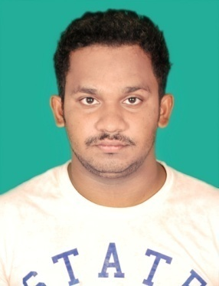

**Name:- Sushanta kumar sahoo**

**Email Id:- kumarsushanta121@gmail.com**

**Mob No:- 6372924283**

**Address:- At/Po/Ps:-Telkoi**

**Dist:-Keonjhar, State:-Odisha**

**Pin:-758019**

**CARRIER OBJECTICS**

To start my career with an organization where I could add value to the organization for the mutual success by using my technical knowledge and skills.

**ACADEMIC QUALIFICATION**

* Completed graduation from Banki (auto) College,Banki under Utkal university,Odisha in the year 2017 having 61.7%.
* Completed 12th from Kalinga Xavier science&commerce College,Jajpur under CHSE Board in the year 2014 having 56.5%.
* Completed 10th from Telkoi High School,Telkoi under BSE,Odisha in the year 2012 having 68% .

**PROFESSIONAL QUALIFICATION**

* Completed Hardware And Networking at Jetking Learning Center,Bhubaneswar in the year 2018.

**TECHNICAL SKILL**

* Computer Typing.
* Assembling & Disassembling Of Laptop, Desktop etc.
* Trouble Shooting networking & hardware computer&software installation.

**FIELD OF INTEREST&EXPERIENCE**

* Government and Corporate Organization company.
* Excel mining company in IT department 15 day only.

**PERSONAL DETAILS**

* Father’s Name:-Gopala Chandra Sahoo
* Mother’s Name:-Nalini Sahoo
* D.O.B:- 01/01/1997
* Gender:- Male
* Languages known:-Odia,Hindi,English
* Marital status:-Unmarried
* Nationality:-Indian
* Strength/Weakness:-Never give up until finished my work.
* Hobbies:-I love to Watching Movies ,Playing Cricket,Video Games.

**DECLARATION**

**I hereby declare that all the details furnished above are true to the best of my knowledge and belief**.

**Date :-25/04/2021**

**Place:- Telkoi Sushanta kumar sahoo**

Signature