**PINTU MAURYA, (CA Inter, M.com, PGDFM)**

Email: [pintumaurya88@gmail.com](mailto:pintumaurya88@gmail.com) Phone: 91+7738445500

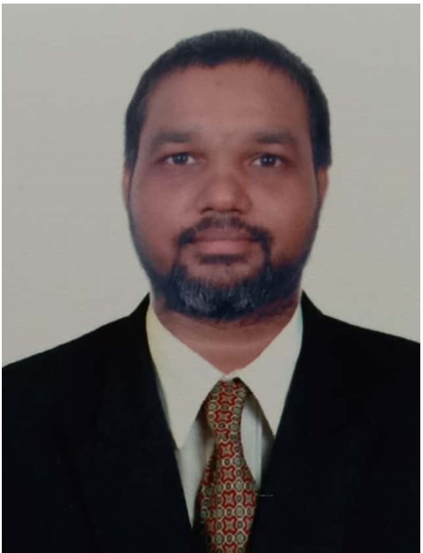



**Working Experience (8+)**



**Asus Technology Pvt Ltd (Asus Group) (September-2018 to till Date)**

**Working as Assistant Manager in Finance and Accounts**

* TDS Monthly payments and filling Quarterly Returns.
* Finalizations of Books of Accounts
* GST Monthly payments and Working of filling Returns.
* Monthly Closing of Books and Reporting to H.Q(Taiwan)
* All Other Works Same Mention Below

**Di-Mentions Studio LLP (Digital Advertising Agency from June-16 to Sept-18.**



**Worked as Assistant Manager in Finance and Accounts**

* TDS Monthly payments and filling Quarterly Returns.
* Finalizations of Books of Accounts
* GST Monthly payments and filling Returns.
* Solving all problem related to TDS on TRACES Portal
* Monthly payment of Service Tax and and filling Service Tax Return
* Preparing data for Income Tax scrutiny
* Handling Audit and related works and preparing Financials.

**K.H. Rawal & Associates Working as Freelancer from 01.04.2015 to 15.04.2016(1 year)**



**Assignment -2(Ambit Holding Pvt. Ltd)**

* TDS Monthly payments and filling Quarterly Returns.
* Solving all problem related to TDS on TRACES Portal
* Monthly payment of Service Tax and and filling Service Tax Return.
* Assiting in CERA Audit
* Maintaining Monthly Cenvat Register

**Assignment -1(PEEL WORKS OUTSOURCING PVT.LTD.**

* TDS Monthly payments and filling Quarterly Returns.
* Monthly payment of Service Tax and and filling Service Tax Return.
* Preparing data for Income Tax scrutiny

**S.P SOMAIYA & ASSOCIATES (C.A Firm)(5.6 Years)**



**Working as Tax Executive** - 01-07-2011 to 30-06-2013 (2 Years)

**Worked as an Articled Assistant** - 01-01-2008 to 30-06-2011 (3 Years 6 Months)

- Direct Tax Exposure and Indirect Tax Exposure

- Handling Client solving their query Related to Taxation





**Personal Development**



* Learned how to work in Team and meet the Deadlines.
* Ability to work in challenging environment
* Honest and Hard Working
* Completing work on Dead line



**Qualifications**



* **PROFESSIONAL**

|  |  |  |  |
| --- | --- | --- | --- |
| **Degree** | **Institute** | **Year** | **Status** |
| C.A. Inter(PCC) | ICAI | May 2011 | Passed |
| C.P.T | ICAI | Nov-2007 | Passed |

* **ACADEMIC**

|  |  |  |  |
| --- | --- | --- | --- |
| **Degree** | **School/College/Institute** | **Year** | **Percent** |
| PGDFM | Mumbai University | 2016 | 70.75 |
| M.Com | Mumbai University | 2013 | 58.00 |
| B. Com. | Mumbai University | 2007 | 72.57 |
| H.S.C | Maharashtra State Board | 2004 | 59.17 |
| S.S.C | Maharashtra State Board | 2002 | 62.26 |



**Computer Skills**



* Working in a fully computerized environment having Proficiency in MS-Office.
* Good knowledge of Computerized Accounting in (Tally-7.2,9 and ERP)
* Tax Preparation Software Winman.



**Personal Skills**



* Ability to work in a team environment
* Initiative and desire to excel
* Proven track record of client service
* Work two years as NSS Volunteer



**Hobbies & Interests**



Listening Music, Reading Books, Research on particular problem and find their solution and to keen New Activity and Big Fan of South Indian Movies.



**Personal Details**



|  |  |  |  |  |
| --- | --- | --- | --- | --- |
| **Date of Birth** | 04th February, 1988 | **Nationality** | Indian |  |
| **Gender** | Male | **Marital Status** | Single |  |
| **Father’s** | Mr. Vijaynath Maurya | **Languages known** | Hindi, English, Marathi, Gujarati |  |
| **Name** |  |
|  |  |  |  |
| **Passport No.** | J1693279 Validate upto | 11.08.2020 |  |  |
| **Residence** | R.N-3, Ramdev Yadav Chawl, S.N.Dubey Road, Rawalpada, Dahisar-East, Mumbai-68 | | |  |
| **Add** |  |
|  |  |  |  |
|  |  |  | **-------------------------** |  |
|  |  |  | **(Pintu Maurya)** |  |