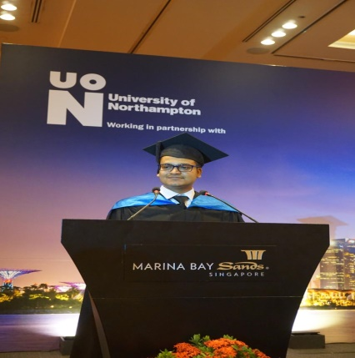

[rohitbhatnagar18@gmail.com](mailto:rohitbhatnagar18@gmail.com)

+91-8899922221

**Rohit**

**MBA Graduate**

**Bhatnagar**

**ABOUT ME**

Completed **Master of Business Administration (MBA)** Program at University of Northampton (in collaboration with Amity Global University, Singapore) with previous **2** years of concurrent experience in BFSI domain. I have worked on Marketing Analytics for banking client (India), done campaign management in credit card, Strong knowledge of all phases of SDLC and Software testing (Functional, Integration). I believe that my experience is paired with my on-going studies and makes me a strong candidate for a global opportunity. I am a diligent worker and passionate about my work. I continue to seek opportunities to grow and further develop my marketing skill-set in dynamic positions.

**EDUCATIONAL QUALIFICATION**

**EXPERIENCE**

**Since Feb’13 - till March’15 Plotel Solutions, Chennai Junior Software Engineer**

**Client – RBL Bank**

**Key Responsibilities:**

* Worked on banking retail product (credit card) development and testing.
* Writing and updating SQL queries to support the daily report.
* Involved in testing the new functionality using and manual and automation scripts.
* Understanding the functional specifications.
* Deriving test cases from business use cases.
* Responsible for completing SIT for the release

**MAJOR MBA PROJECTS IN SINGAPORE**

* **The Impact of Social Media on Marketing Strategies :**
  + Identify and evaluate current debates over the nature and processes of globalization.
  + Analyze the global interaction between transnational corporations, governments and global institutions.
  + Analyze the differing impact of, and responses to, global economic transition and transformation on the part of specific regions and states.
  + Research, evaluate and present several contemporary debates or issues in strategic management, focusing on the relationship between theoretical work in the field and a range of experience within organizations and industry sectors.
  + Analyze and explain the implications of current trends for future strategic decision-making
* **Business Report on Pollution Eating Bikes and Make PESTEL analysis (External environment) in China.**
  + Critically select and apply relevant marketing theories, conceptual models and frameworks in the development of marketing strategies within a dynamic business environment to produce superior marketplace performance.
  + Demonstrate knowledge applied to evaluate marketing practice in relation to the cross-functional aspects of business & management with the goal of enhancing long-term shareholder value.
* **Project on Sheng Siong Group- Critically financial Analysis for future Profitability**
  + Analysis and explain the profitability ratio and compare the profit trends with competitors(NTUC)
  + Evaluate the Liquidity Ratio and Dividend Ratio to analyze the future Investment plan
  + Analyze the Horizontal and vertical Balance sheet and Income statement of the Group
* **The Impact of Leadership In 21st century**
  + Analysis the classical theories and compare with contemporary theories.
  + Challenges of Leadership in 21st century.
  + Key competencies for 21st century leaders
* **Business Report on Company strategy on STP (Segmenting, targeting and positioning)**
  + Analyze the STP model on Singapore Airlines and evaluate its strategy to attract the customer.
  + Evaluate the strategy of UBER and make a comparison with GRAB and analyze its challenges
* **Industry Analysis on “INDUSTRY 4.0” and Time Based Competition**
* **Completed project on “Opportunity Analysis”(How can we start up a new idea successfully)**
* **Business Management Research Project on “REVERSE INNOVATION IN MARKETING STRATEGY**

**KEY STRENGTHS AND IT SKILLS**

* Good Interpersonal abilities and creative Problem Solving
* Ability to work flexible hours by stretching based on the project need
* Hardworking, perseverance in work related problems, punctual, enthusiastic
* Fast and a good learner
* Excellent communication skills
* Conversant with MS Word, MS Excel, MS PowerPoint and Window XP/Vista/7, SAS, Teradata, UNIX and SQL.

**CERTIFICATIONS**

* Certification course in CCC Basic computer fundamental.
* Certificate of participation in a workshop on Java Technology focus on Industrial software Development.
* Certificate of participation in Amity’s 7th International Conference on Managing Diversity in Business and technology: Challenges of The Global Contemporary Workforce
* Participated in sales and marketing workshop conducted by IMM.

PERSONAL DETAILS

Date of Birth: **18 September 1991**

Language known: English, Hindi

Marital Status: **Single**

Passport number- **Z3174923**