CONTACT

DEBARGHA DAS

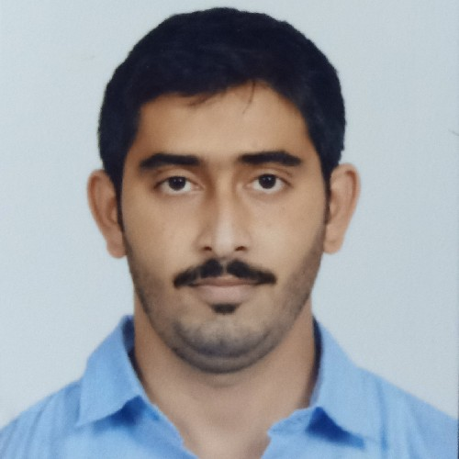 [debar](mailto:debarghadas360@gmail.com)[ghadas360@gmail.com](mailto:ghadas360@gmail.com)

 8981725397

 BISHARPARA KODALIYA, NORTH

SAPTAGRAM, NORTH 24 PARGANAS KOLKATA- 700158

OBJECTIVE

I would like to associate myself with professional organization which has the potential future and ample score of learning and further enhance my skills through constant

learning and challenges in work. To seek a challenging and prospective career in marketing ﬁeld with a purpose full participation and to work in an innovative and competitive world.

EXPERIENCE

*10/01/2020 - TILL DATE*

*25/07/2019 -*

*09/01/2020*

*01/02/2019 -*

*24/07/2019*

*25/05/2015 -*

*01/02/2019*

*12/12/2012 -*

*25/05/2015*

EDUCATION

*2012*

*2009*

*2007*



OVERSEAS HEALTHCARE PVT LTD

AREA SALES MANAGER

WORKING AS AREA SALES MANAGER IN NORTH KOLKATA, BARASAT AND BASIRHAT.

HETERO HEALTHCARE PVT LTD

AREA SALES MANAGER

WORKED AS AREA SALES MANAGER IN NORTH KOLKATA AND CENTRAL KOLKATA.

GLAXO SMITH KLINE

MCE

WORKED AS MCE AT NORTH KOLKATA.

CIPLA LTD

THERAPY MANAGER

WORKED AS THERAPY MANAGER AT NORTH KOLKATA WITH EXPERIENCED IN APOLLO, AMRI, CHARNOK, CALCUTTA HEART CLINIC, COLUMBIA ASIA.

ZYDUS BIOCHEM

TERRITORY SALES EXECUTIVE

WORKED AS TERRITORY SALES EXECUTIVE AT CENTRAL KOLKATA.



WEST BENGAL STATE UNIVERSITY

B.SC



VIVEKANANDA HIGH SCHOOL

HIGH SECONDARY EDUCATION MADHYAMIK

K.K. HINDU ACADEMY

SKILLS

* Overall experience is 8 years in the pharmaceutical industry. • Strong, productive and ﬂexible team player and believe in total participation with positive attitude. • Self-

motivated and hard working. • Good communication and interpersonal skills. • Better computer knowledge of Microsoft oﬃce.



ACHIEVEMENTS & AWARDS

* Achieved 3 times best achiever award from 2016-2019. • Achieved 20% continuous growth with 7.5 lac productivity. • Awarded with foreign trip by Cipla Ltd. • Achieved more than 100% in sales parameter from December'2019 to till date.

PERSONAL DETAILS

Date of Birth : 07/08/1991 Marital Status : MARRIED

Nationality : INDIAN

Father's Name : MR. ARUN KUMAR DAS

Language Known : ENGLISH, HINDI, BENGALI

DECLARATION

Hereby declare that the above given information is true as per my knowledge and believe.

PLACE- Kolkata DATE-