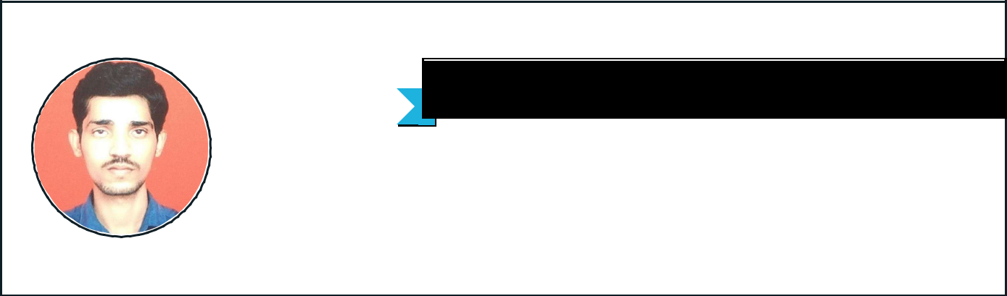
SACHIN

H NO: 1/1/77 WARD NO: 02 , RAYAPPA CHALI KASHI GALLI

CHITTAPUR-585211
+918151012219

hsachin180@gmail.com


CAREER OBJECTIVE 

EDUCATION

EXPERIENCE

TECHNICAL SKILLS

PROJECTS

Seeking the role of Mechanical Engineer Experience where I would be given an opportunity to learn the practical skills, sense of responsibility and to be a part of innovative projects undertaken by the organization.F

SRI JAYACHAMARAJENDRA COLLEGE OF ENGINEERING MYSURU BE(MECHANICAL ENGINEERING)
8.78 CGPA or 80%
2018

GOVT POLYTECHNIC SURAPURA

DIPLOMA (ME)
76.76%

2015

MAHATMA GANDHI HIGH SCHOOL CHITTAPUR

SSLC
67.04%

2012

BHARAT ELECTRONIC LIMITED BANGALORE

PRODUCTION PLANNING AND CONTROL
9 Months -

PRODUCTION CONTROL DEPARTMENT

CATIA SOFTWARE

ANSYS
SOLID EDGE

SAP (PP MODULE)

NATIONAL CART 6 Months

I have a part of the team METALART which is participating in the nationwide go kart
competition NKRC for the year 2017.Being one of the design team members; I worked under steering system.

TRACKER MOUNT Currently doing

Tracing device mile way for sea level around 100KM on the sea area.

INTERESTS

PERSONAL

STRENGTHS

ACTIVITIES

ACHIEVEMENTS & AWARDS

PERSONAL PROFILE
DESIGN ENGINEER
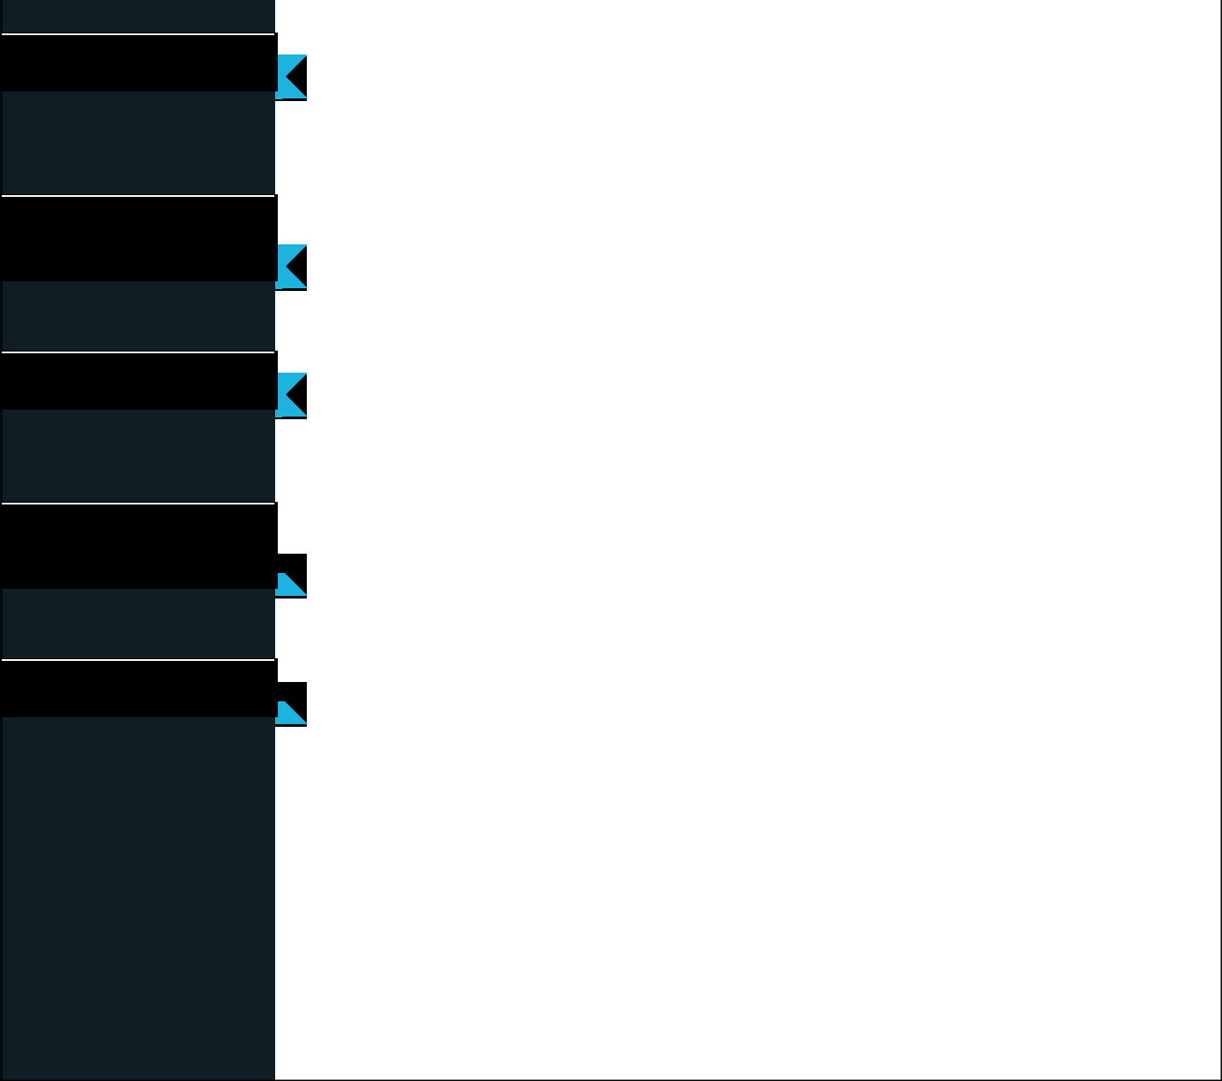

INDUSTRIAL MANAGEMENT
MANUFACTURING

AUTOMOBILE INDUSTRY

I like to exhibit patience with a sense of urgency. I try not to let my customers see that my workload is heavy, yet I try to work at maximum efficiency.

Electronic Voting Machine

National Kart
Automobile Work Shop

NATIONAL KART

Date of Birth : 22/07/1996

Marital Status : SINGLE

Nationality : INDIAN

Known Languages : ENGLISH,MARATHI,HINDI, KANNADA

Hobby : Cricket, Swimming, Drawing

Date : 01/09/2019

Place : BANGALORE

