RESUME

TIKAM 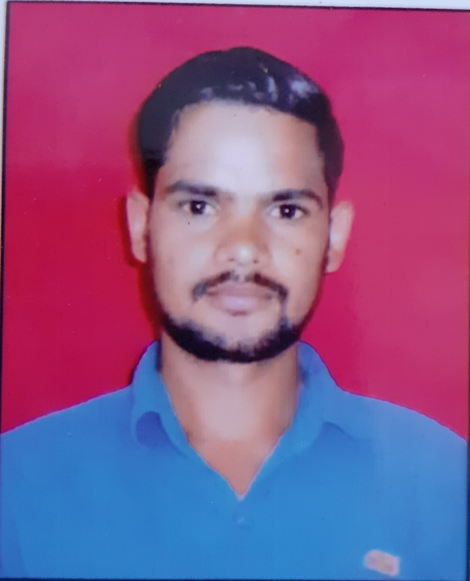
Village - Didhara
Teh. Tauru
District-Nuh.122105
Mobile: +91 8930518736

E-mail: tikamtanwar143@gmail.com

CAREER OBJECTIVE

I believe in giving the best of my work. I enjoy taking on responsibilities and working with a strong sense of loyalty, sincerity and commitment. Seeking a position in the accounting field where excellent analytical and technical skills can be utilized to improve the company's profitability.

CAREER PROFILE:
- Possess strong analytical and problem solving skills, with the ability to make well thought out decisions.
- Excellent written and verbal communication skills.
- Highly trustworthy, discreet and ethical.

WORK EXPERIENCE

- Instakart Services Pvt. Ltd. through Arcos Skill Management Services Pvt. Ltd as a “DEO” from 12-Apr-2016 to 15-May-2018.”
- Currently working in Aditya Birla Group (Kerry Indev) as a Outward & Inward Supervisor from 16-May-2018 to till date.

COMPUTER
.
- One Year Computer Diploma passed from Deeplaya Computer Centre Tauru

ACADEMICS

- Passed B.A from MDU Rohtak

- Passed 12th from Board of School Education Haryana (Bhiwani)

- Passed 10th from Board of School Education Haryana (Bhiwani)

EXTRA CURRICULAR ACTIVITES

- School sports organiser.
- Participate in all activities.

STRENGHTS

- Hardworking, determined, dedicated and result oriented.
- Eager to learn and contribute.
- A good team worker & leadership quality.

PERSONAL DATA

Name : Tikam
Father’s Name : Sh. Mohar Singh
Date of Birth : 02/09/1992
Sex : Male
Religion : Hindu
Nationality : Indian
Marital Status : Married
Language Known : Hindi, English
Hobbies : Reading Books & Playing

I, hereby declare that all the information given above is true and I hold the responsibility of its authenticity.

Date:
Place: (TIKAM)

